# Human Tissue Authority Board Meeting

**Date:** 21 September 2023

**Paper reference:** HTA 24/23

**Agenda item:** 9.

**Author:** Louise Dineley

# Data Digital Update

## Purpose of paper

1. To update the Board on the strategic direction of digital and data including progress against the 2023/24 Business Plan.
2. To provide the Board with an overview of data, its significance and role in regulation, ongoing development and issues emerging from horizon scanning.
3. To discuss future regulatory requirements relating to greater use of data and digital activities in the services and activities that the HTA regulates.

## Decision making to date

1. The SMT received and noted an outline of the HTA’s Data and Digital Vision for 2023 and beyond in March 2023.
2. The Board approved the 2023/24 Business Plan in March 2023 that identified a commitment to explore a shared service model for future IT provision to support digital development and a series of phased developments in the use of data.

## Action required

1. The Board is asked to note the strategic direction for data and digital developments and intended deliverables by 31 March 2024.

## Background

1. Over the last 3 years the HTA has set a strategic direction for the development of its digital and data capacity and capabilities. These aspirations, built on the foundations set with the adoption and transition to MS365 in 2020 included the development of infrastructure, based on business requirements and the interoperability of internal systems. Thus, optimising the full of use of MS applications available to the HTA as part of its digital licences and the development of its use of data to promote greater insight in terms of the HTA’s impact and its ability to respond to emerging areas of risk.
2. The realisation of the HTA’s strategic vision for data and digital services has been dependent on the availability of targeted annual investment and a commitment to phased programmes of development for whole scale change and realisation of benefits (efficiency, effectiveness and economics).
3. This commitment and investment of resources has been critical in maintaining ambitious and deliverable plans that reflect and are in line with wider strategic digital vision both internal and external to the HTA. The significance of this investment is even more important given neither the skills nor the capacity exist within the internal, business as usual (BAU) resource of the HTA.

## Business Plan Commitments

1. In 2021/22 investment was withdrawn from planned data and digital developments based on financial pressures that were identified in Q3. As a smaller organisation, securing the required investment and resource commitment to IT is a continual challenge. It was suggested that alternative models of delivery and IT service provision would need be considered. As part of the 2022/23 Business Plan, it was agreed that the HTA would explore options and potential partners for the delivery of an IT Shared Service model(s). This focus on alternative models of delivery, meant that the following projects were halted and earlier plans to strengthen the capability of our systems was delayed until a way forward was confirmed.
2. Business process mapping (including data flows) of the “as is” and “to be” models of the HTA’s regulatory approach and the systems (manual and digital) used.
3. Design of system architecture to support a future targeted operating model that is flexible and responsive to emerging sectors, technologies and areas of risks.
   * Progression of phases 2-4 of an Enterprise Content Management System. A fundamental change and development that would enable greater use of the totality of the information, intelligence and insight collected by the HTA.
   * Development of the proof of concept “Regulatory Insight Model & Index” to

a practical data and risk engine.

1. The impact of under resourcing is that HTA systems have not kept pace with internal and external developments. This has resulted in a continued reliance on manual interventions with respect to data processing, duplication of activities, information recorded inconsistently and in different systems and lack of insight based on the collective corporate knowledge held by the HTA.
2. In the absence of the required resourcing (people and financial investment), expectations on progress and realisation of the benefits were unadjusted.
3. In 2022/23 the strategic direction of data and digital developments was steered by two specific projects, firstly, IT Shared Services and secondly a rescoped Regulatory Insight Model and Index (RIMI) aimed at supporting the development of the use of data.

## IT Shared Services

1. The IT Shared Services project sought to explore the potential opportunities and benefits that may exist in the HTA partnering with a larger organisation either as a supplier of IT services or as part of a joint commission. The potential for a joint commission is something that was considered and acted as a potential driver to the centrally co-ordinated work on shared services and the opportunities that may exist across a range of functions. This work continues in the background.
2. Over the last 12 months in line with the business plan, the HTA has progressed work to explore the potential to strengthen the resilience of HTA’s IT service provision through a shared service model. This work has included:
   * The development of an agreed service catalogue providing a detailed specification of support, services and resource requirements.
   * A vision for data and digital developments in line with business requirements and external drivers.
   * Completion of an exploratory stage of current IT provision and strategic plans across Arms Length Bodies (ALB).
   * Maintenance of an operational function that has continued to support operational delivery.
3. In July 2023, the HTA completed a high-level discovery exercise with a possible partner (another ALB). The scope of the high-level discovery was to determine

the overall financial affordability of the model and transition. Financial affordability had been a recognised risk from the outset. SMT reviewed the findings of the discovery phase in late August, concluding that the move of IT to a shared service model was not currently affordable and would not be progressed independently.

1. Despite the outcome, the exercise provided some valuable learning and insight. The work has confirmed the complexity of an IT Shared Services project for a small organisation with limited, dedicated resources (financial and people). It has also highlighted the upfront commitment and investment that is needed to prepare for the transition and the impact that this has in terms of potentially diverting resources from ongoing maintenance and development of existing systems and service delivery.
2. There has been an impact and cost to the HTA’s current IT systems. Most significantly, there has been a delayed and deferred investment to upgrades to systems such as, although not limited to, CRM over the last 2 years. Overdue upgrades to CRM and other systems have already been identified as priority projects for consideration in 2024/25.
3. The project to explore a move to a shared service model has confirmed that it is not practical or affordable for a small organisation such as the HTA (operating within current financial and budgetary constraints) to successfully adopt a shared service model in IT without a significant impact on its regulatory responsibilities. For this to be a viable option, the HTA would be looking to be part of an at scale commission centrally led and co-ordinated across ALBs. The potential for this to be an option was previously explored across ALBs at the end of Q4 2022/23 although not taken forward. The HTA is keen to explore with DHSC and other ALBs, the potential for this option to be reviewed and reconsidered in the future.

## Strengthening the use of data

1. Work to develop a revised Regulatory Insight Model & Index (RIMI) commenced in Q2. Work in progress includes:
   * The development of a core set of metrics drawing on internal and external data sources.
   * An assessment of outputs from the data collection project.
   * Draft commission for required support and technical specification for the “engine” and platform. This commission is currently being drafted in line with ongoing spend controls and approvals. The commission is supported by a business case that will be submitted to DHSC by the end of Q2.
2. In addition to the two identified projects, there have been further activities to strengthen the use of data as part of day-to-day operations. This has included the two planned publications of HTA data sets since April 2023, internal scrutiny of data sets to identify themes and trends for further investigation and the use of data in assessing the impact of HTA’s activities.
3. These data sets published in June and Sept are as follows:
   * Inspections (April 2017 – March 2022)
   * Inspections (April 2022- March 2023)
   * General enquiries (April 2017 – March 2022)
   * General enquiries (April 2022 – March 2023)
   * Shortfalls (April 2017 – April 2021)
   * Shortfalls (April 2022 – March 2023)
   * Licences granted (August 2023)
   * Licences ceased (August 2023)
   * Licence Variations, Licence Applications, and Licence Revocation Requests (April 2017 – March 2022)
   * Licence Variations, Licence Applications, and Licence Revocation Requests (April 2022 – March 2023)

## Data & Digital Vision

1. The HTA’s Data & Digital Vision is outlined in Figure1.
2. This vision is consistent with the National Data Strategy and central drivers for realising efficiencies, increased use of available data and the opportunities for reform in regulation. It is hoped that this approach will continue to support and secure progress in the developments to digital capacity and capability and help to realise efficiencies and wider benefits for how the HTA regulates.

Figure 1: HTA Data & Digital Vision

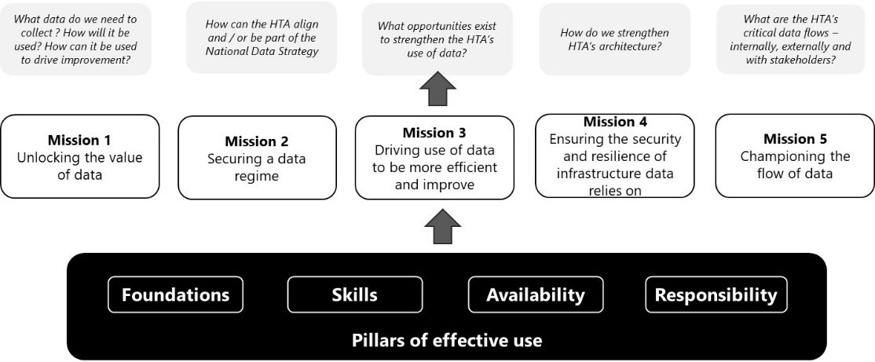

1. The vision can be easily translated into key actions to aid sustainability and resilience of the HTA’s information management and tech systems. Actions identified in the 2023/24 Business Plan include:
   * Planned transition to an IT Shared Service model 23/24: Baseline assessment and high-level discovery to determine viability of a shared service model. Status: Completed.
   * IT strategy requirements 23/24: a systematic assessment of current systems, architecture, use and future options for systems nearing or out of support. Status: Active – Great Plains and CRM identified as priorities for investment in 2024/25.
   * System capability to support incremental development of D&I model and regulatory approaches 23/24: Design and implementation of a change control process. Status: Active – draft framework in place to be finalised and operationalised in Autumn 2023.
   * Development of a risk engine to support the identification of risk to deploy the appropriate regulatory response and to provide greater insight into the changing landscape including emerging areas of risk and the impact of HTA actions. Status: Active – PID and Business Case drafted and awaiting approval. Potential for allocated funding to be at risk due to current financial pressures. Project has been rescoped and supplemented with additional stages to address gap in outputs and dependency with the data collection exercise.

## Looking Forward

1. The vision for our data and digital programme spans the immediate term of the remaining financial year and a longer-term vision for 2024/25. In addition, the support that strengthening our data and digital capability will lend to the HTA’s future strategy.
2. In the post pandemic period, there have been numerous publications that have all identified the value and impact that strengthened use of data and digital solutions are expected to have on health and the wider life sciences. The underpinning direction of travel has not changed, although the pace has been accelerated and the ambition is fuelling what can be achieved through the use of technology and digital innovations. There are various examples across life sciences that include automated processes, new technologies underpinning change or in accelerating the pace of research. The learning from each change increases appetite and ambition for what is possible. These additional drivers are reflected in several emerging developments such as; the use and application of Artificial Intelligence, emerging technologies and changes in care settings.This is not intended to be an exhaustive list although does indicate the breadth of change and the potential to impact HTA regulated and non-regulated activities.
3. There are several current and future considerations on the changing data and digital landscape. These include:

* The results of horizon scanning and specific areas of development and innovation making use of new technologies.
* The McLean review on the regulation of pro innovation technologies has highlighted the need for the opportunity for greater alignment across the system. The HTA is currently working with other ALBs to take forward the recommendations in the review. This follows an initial roundtable in July which identified opportunities in evidence and data collection.
* The HTA has been approached by NHSE to explore and participate in a national data repository. Conversations are at an early stage and further information is required to understand if this could offer the “data lake”

concept previously explored and HTA’s access to data and insight. Based on the learning from the IT Shared Services project, the HTA needs to be able to access and consider collaborations such as these as part of development plans. External drivers for data and digital development

* The HTA is committed to continually improving access to its data and information. Since April 2023, the HTA has completed two rounds of publishing data sets related to regulatory activity and its findings. The openness and use of the data by others is something we are keen to continue and evaluate in terms of its wider use. We are committed to

publishing data sets twice a year with the next scheduled publication at the end of 2023/24.

1. Our next steps are to continue to progress the development of data indicators and the risk engine through the remainder of 2023/24, subject to investment. Where possible and practicable the HTA will seek to work in partnership and potentially collaborate with organisations within the system to minimise any additional burden on those already regulated.

## Recommendation

1. The Board is asked to note the strategic direction for data and digital developments and intended deliverables by 31 March 2024.