Human Tissue Authority
Board Meeting

Date: 21 September 2023
Paper reference: HTA 23/23
Agenda item: 8.
Author: Nicolette Harrison

Innovation in Inspection
Purpose of paper
- To provide the Board with an update on our progress in innovating our approach to inspection activity through the Review of Inspections Project and the development of Evaluated Self-Assessments (ESAs).
- This paper sets out current early thinking on prioritisation for implementation of options emerging from Phase 1 of the Review of Inspections Project and the steps we have taken to continue in-house innovation through the development and piloting of ESAs.
Action required
- The Board is asked to note our plans to continue to innovate our approach to inspection and to make any strategic comments they feel pertinent.
Background
- The HTA has devised, trialled and implemented various innovations in inspection in recent years, including introducing Virtual Regulatory Assessments (VRAs).
- We have supplemented our home-grown approach to innovation through financial investment in the Review of Inspections Project.
- We are currently considering the outputs of the initial report from Phase 1 to determine priorities to take forward for implementation. We will be considering next steps for Phase 2, including any further refinement of scope, through our 2024/25 planning.
- ESAs are an internal development from within operational delivery, building on previous innovations. The ESA concept was developed over the latter part of 2022/23 and is being piloted in the Research sector in the first half of 2023/24.
Review of Inspections Project
- Four wide-ranging themes emerged from Phase 1:
  - Planning and scheduling of regulatory activity;
  - the use and effectiveness of VRAs;
  - segmenting Regulation Managers workload; and
  - recording and reporting of data.

- Annex A presents some key findings from Phase 1 in diagrammatic form. Key findings include:
  - ‘post-inspection activity’ amounted to up to 60% of the time spent on ‘inspection-related activity’; and
  - hybrid inspections and some VRAs were taking significantly longer than purely on-site inspections because of an increased amount of time being spent reviewing documents online.
- Phase 1 also captured other qualitative data and quantitative observations, including frontline insight, which we will be critically assessing with colleagues across the HTA over coming months.
- Our initial high-level assessment of anticipated ease and costs of implementation against likely impact (benefits and disbenefits) identified some options to be adopted through continuous improvement processes, and to be incorporated in scope for the 2024/25 business planning process.
- These included further refinement and development of our policies and processes focusing on improving efficiency, removing redundancy and ensuring that activities are truly risk-based and proportionate, including our approach to assessment and management of shortfalls.
- A fundamental review and change to processes is out of scope as this would require significant change and investment in our systems, including CRM.
- We also plan to improve resilience and flexibility by ensuring that all Regulation Managers are competent across at least two sectors.
- Options requiring a fundamental redesign of processes and technological solutions, and therefore to be considered for the longer term, is replacing Inspection Workbooks, making inspection findings fully digital to include searchable shortfall data, and streamlining the end-to-end CAPA process.
- Options requiring structural change, such as new functional units for discrete elements of the inspection process, are not considered a priority.
- Prioritising continuous-improvement type change through BAU delivery in 2024/25 is not cost or impact-free. However, we believe this approach will be cost effective and is more likely to result in manageable change and rapid delivery of benefits. The 2024/25 planning process should ensure we fully capture and address costs and impact across the whole organisation.
- Benefits will include reduction in average time spent on the inspection process, not least, less time spent on document review and post-inspection activities. Increasing the efficiency of inspections is a key facilitator of the drive to address the risk of sectoral harms through greater knowledge and, where appropriate, greater coverage of our sectors through suitably targeted, risk-based and proportionate inspection processes. Improved efficiency should also enable us to free-up frontline resource from inspection processes towards other key regulatory functions.
Evaluated Self-Assessments (ESAs)
- The HTA has been developing ESAs as an addition to our portfolio of inspection types. Initial development and piloting has been in the Research sector, beginning with a limited test and learning trial of 7 ESAs in Q2.
- We intend to incorporate learning from the initial pilots into refined templates and processes in preparation for a more extended trial in the second half of the year and aim to undertake 30 by the end of the year.
- Key matters to be finalised include reporting the outcomes of ESAs, how to use the outcomes to inform risk profiling, if, when and how ESAs could be adopted in other sectors and identifying the optimal solution for undertaking the self-assessment questionnaire (given we are currently using Microsoft Forms).
- Decisions on next steps will be taken as part of the business planning process for 2023/24, including how best to take forward the development and adoption of ESAs in the 2024/25 inspection programme.

Recommendation
- The Board is asked to note our plans to continue to innovate our approach to inspection and to make any strategic comments they feel pertinent.

Annex A: Key findings Review of Inspections Project (Figures 1–6)
Figure 1: As-is inspection process indicating breakdown of time spent on each phase
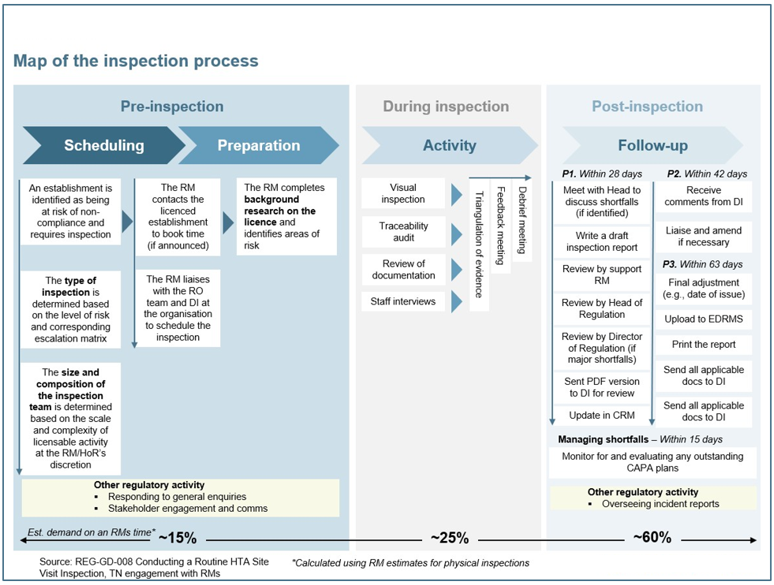
Figure 2: Graphical representation of changes in inspection numbers pre- and post-Covid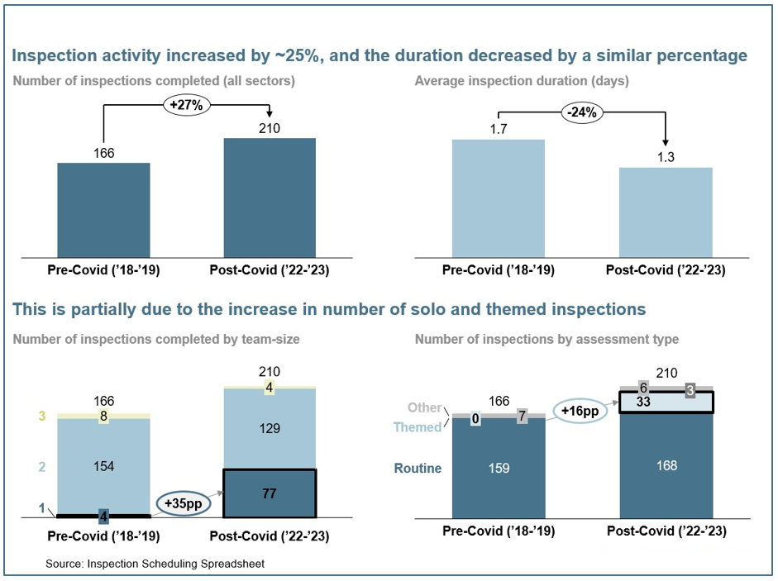
Figure 3: Profile of different types of inspection by sector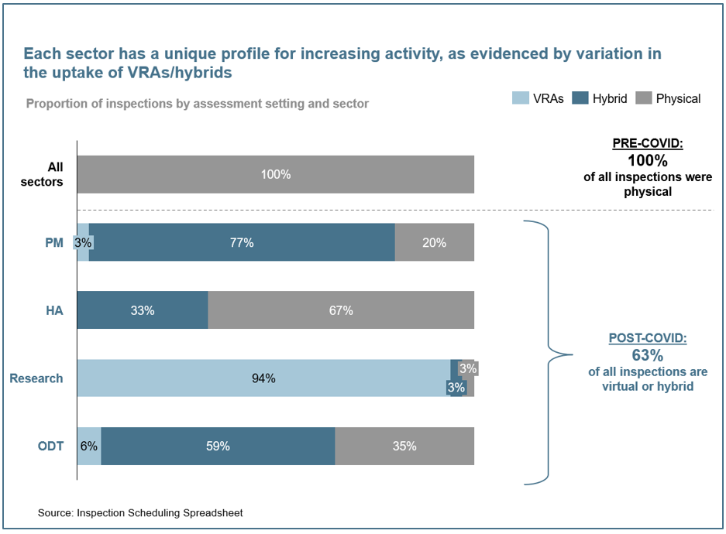
Figure 4: Overview of shortfall findings by criticality level across all sectors and in the PM sector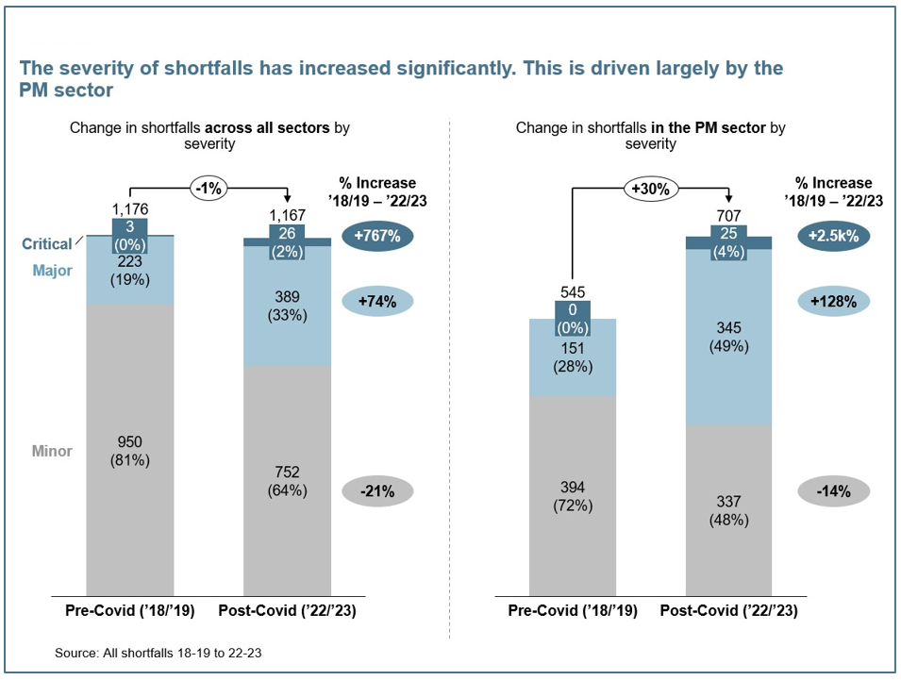

Figure 5: Graphical representation of time spent on key aspects of the inspection process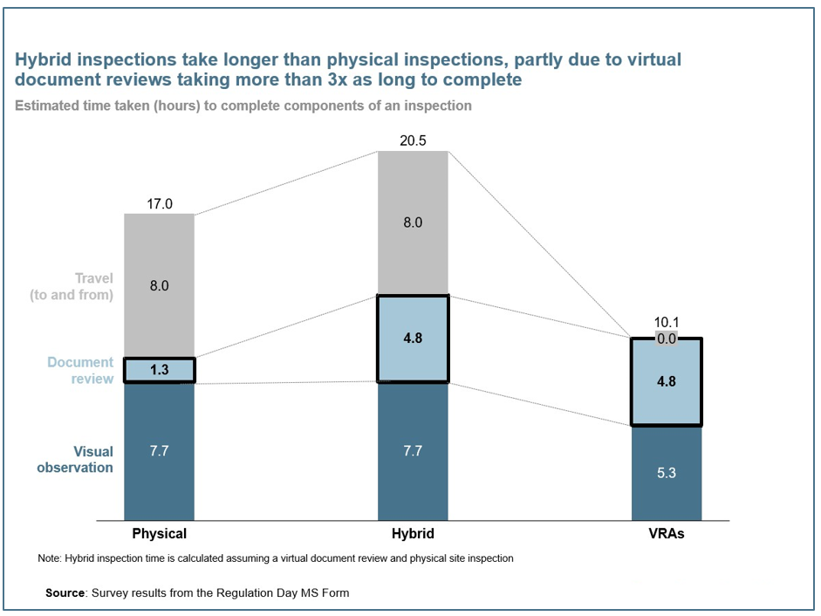

Figure 6: Inspection process with summary of average time spent on the main elements