**Human Tissue Authority**

**Board Meeting**

Paper reference: HTA 21/23

Agenda item: 6.

Author: CEO and Senior Management Team

**HTA Performance Report**

Introduction

1. This paper informs the Board of the HTA’s performance in Quarter 1 (Q1) against our objectives and operational delivery targets.
2. In addition, it provides an early indication of the initial performance in Quarter 2 (Q2).
3. Core areas of operations from our Business Plan with formal Key Performance Indicators have been included as topics within the paper, in the same order and nomenclature as that document, to allow the Board easy read across. **Annex A** provides the KPI and Project Data Overview for Q1 (final) and **Annex B** gives the KPI and Project Data Overview for Q2 (latest).

Action required

1. The HTA Board is asked to note and comment on the performance recorded and the context provided.

Regulation

1. There are four Regulation Directorate KPIs. The KPI in relation to median age of open Corrective and Preventative Action plans had been off-track in April and May but had been brought back on track by the end of June. Indeed, at the end of June all operational KPIs are green. By contrast, during Quarter 1, whilst all four projects managed from within Regulation Directorate have been progressed three out of the four were at Amber and one was at Red status, in each case principally because of resourcing issues. The KPI for successful completion of all HA inspections due for the year within the statutory two-year time period is only reported at the end of the business year.
2. Activity to continue to develop our regulatory role in connection with organ donation and transplantation, including responding to the introduction of the amendment to s32 of the Human Tissue Act, remains at red because of an acute lack of resource. The Head of Regulation for ODT has presented at meetings to raise awareness of the S32 offences amongst the clinical community.
3. The actions to which we have committed, to strengthen our existing Living Organ Donation (LOD) approvals process, are progressing and were on track at the end of Quarter 2 for activities to be accomplished by then. The resourcing issue may impact our ability to keep this on track later in the year.
4. The LOD Team has continued to be busy above and beyond normal levels of activity with complex casework and enquiries. During Quarter 1, the HTA referred 4 cases of potential Human Tissue Act offences relating to LOD to the police. This is a creating a significant resource pressure for which additional support from DHSC is being sought.
5. The Head of Regulation for ODT has continued to meet with the staff of the NHS Trust involved with the LOD procedure which took place before HTA approval had been given in Quarter 4.
6. The Data Collection exercise started in Quarter 1 and was largely completed early in Quarter 2. Lack of resources has impacted our ability to fully complete Phase 1 and we are developing options for next steps to undertake Phase 2 (reviewing and analysing the data to develop and take forward actionable insight).
7. Phase 1 of the Review of Inspections work was initiated at the end of Quarter 1, with the draft report received and considered by the HTA in Quarter 2. This has helped inform the Innovation in Inspections paper.
8. Work to develop ‘Evaluated Self-Assessments’ (ESAs), as a further form of inspection, is continuing with an initial test and learn pilot of 7 ESAs to be carried out in the Research sector during Quarter 2.

**Policy & Development**

1. In light of last year’s change to the law which prohibited (for most UK residents) the purchase and sale of organs outside the UK and the conviction this year of three people for the trafficking of a man to the UK for the purpose of removing an organ without consent, the Department of Health and Social Care is planning to clarify the responsibilities of clinicians in sharing information about transplants which take place outside the UK, as well as when they have a reasonable suspicion that an offence under human tissue or modern slavery legislation has taken or will take place. The Department would like this information to be sent to the HTA, who would then decide whether to refer to the police.
2. Operational and Policy teams are currently engaging with DHSC on these proposals. As the proposed change is unpacked, we will need to be clear about what the “ask” of HTA might be, the timescale to implementation, how the approach/system will work, the scale of the associated resources required and how funding would be covered. We will update the Board as the Department’s work unfolds.
3. Q1 also saw the Policy and Development team start two projects. The first project – Assessing our Impact – focuses on exploring the HTA’s value, impact and progress in delivering its strategic mission. It aims to assist the HTA in seeking ways to efficiently improve how it regulates, ensures patient safety, works with stakeholders and provides value for the taxpayer. While the project is due to end in early Q3, its first phase – to explore the HTA’s perceived impact and develop a Theory of Change model – has drawn to a close. The “Theory of Change” gathered ideas and thoughts on current and future ways of working from across the business to identify opportunities for improvement or change. Phase 2 is currently underway and seeks to collect, analyse and validate findings during Q2. The project’s findings and recommendations will feed into the next HTA strategy, an external-facing publication reviewing the HTA’s impact and the public bodies review.
4. A second project – Establishing an Insight Network – also began in Q1 and is in the process of creating a shortlist of potential members. Recruitment of the members commenced in Q2 to support the initial set up of the Insight Network. It is at this point the project will also draw to a close (as the Network will be embedded in an updated Horizon Scanning function).

Communications (including stakeholder engagement)

1. In line with the communications KPI, the communications team handled 15 media enquiries, responding within deadline. Most enquiries related to people trafficking for organ donation following the trial and conviction of individuals under the Modern Slavery Act. The communications team issued a press release following the prosecution and the CEO took part in an interview for the BBC File on Four programme. In total, 9 news items were published in Q1, picking up on live organ donation, publication of our business plan, the introduction of deemed consent in Northern Ireland and updates to HTA codes of practice.
2. The stakeholder plan for 2023/24 was approved by SMT, which includes plans for a face-to-face event to take place in 2024/25. A roundtable on the management of the deceased was held with key stakeholders.
3. In Q1, the communications team focused on fixing the 6 errors that the Government Digital Service (GDS) found in their accessibility test on the HTA website. In addition, we addressed 10 other issues identified in an earlier audit from April 2022. GDS reviewed our improvements and recommended no further action in their report to the Equality & Human Rights Commission. They have also confirmed our statement is compliant. Due to this work, the re-tender for the website has been delayed until Q2.
4. The communications team have supported the delivery of core business, issuing seven Regulatory Updates in Q1, engaging regularly on social media on core HTA business and supported the Board meeting held in public in June. Internally, the communications team supported engagement and core business by developing and publishing a design for HTA’s core values, delivered two Ask the CEO sessions, Q&A sessions with internal staff, and shared regular news roundups.

Information Technology (including data and digital)

1. There is a substantive agenda item providing a more detailed update on data and digital delivery and development. In Q1, performance against the KPIs has been met with no loss of systems or unplanned downtime. There have been no reported threats to the system or vulnerabilities that have been exploited by external attacks.
2. In Q1, we began publishing more of the HTA’s data in keeping with being a more transparent regulator, helping to promote accountability and identify trends and opportunities for improvement. The first dataset was collated and analysed prior to publication in June 2023 and included data pertaining to inspections and enquiries. The second dataset will be released in Q2 and will cover licensing (such as licence variations, new licence applications and applications to withdraw licences) and shortfalls. Both these datasets make pre-2023 data publicly available. A third dataset will be released in Q3 which includes 2023-24 Q1 and Q2 data. Thereafter, datasets will be published on a bi-annual basis, each covering the previous six months of the business year.

Corporate Services

1. During Q1, the HTA received 9 Freedom of Information (FOI) requests. All the FOI requests received were dealt with in line with the statutory timeframe. In Q1, no complaints were received by the HTA.

Finance

1. The table below is the summary position as at the 30 June 2023 (quarter one of the 2023/24 business year) with a surplus against budget of £159k.

**Table 1: Summary income and Expenditure**

|  |  |  |  |  |  |  |
| --- | --- | --- | --- | --- | --- | --- |
|  | **Actuals £000s** | | | **Budget £000s** | **Variance**  **£** | **Variance**  **%** |
| **Income** | |  | |  |  |  |
| Grant-in-aid | | | 273 | 0 | 273 | - |
| Non-cash | | | 27 | 27 | - | - |
| Licence Fees | | | 1,706 | 1,847 | (141) | (7.63) |
| Other Income | | | 158 | 146 | 12 | 8.2 |
| **Total Income** | | | **2.164** | **2,020** | **144** | **7.1** |
| **Expenditure** | | |  |  |  |  |
| Salaries and Wages | | | 966 | 1,032 | (66) | (6.4) |
| Travel and Subsistence | | | 35 | 34 | 1 | 2.9 |
| Other staff costs | | | 65 | 61 | 4 | 6.6 |
| Other operating costs | | | 12 | 6 | 6 | 100 |
| IT & Telecommunications | | | 85 | 92 | (7) | (7.6) |
| Legal / Professional | | | 41 | 34 | 7 | 20.6 |
| Accommodation | | | 61 | 25 | 36 | 144 |
| Non-cash | | | 32 | 28 | 4 | 14.3 |
| **Total costs** | | | **1,297** | **1,312** | **(15)** | **(1.14)** |
| **Net income** | | | **867** | **708** | **159** | **(22.45)** |

**Income**

1. Our income consists of Grant in Aid, Licence Fees including charges to Devolved Governments and secondee income (staff recharges). The in-year variance is a consequence of even budget profiling when income is received variably.
2. Reduction of licence fee income against budget is mainly within the Human Application sector (£162k).

**Expenditure**

1. **Explanation of notable variances are as follows:**

* **Salaries and wages** – are under budget by £66k due to start dates of new starters being slightly different from the budget.
* **Other staff costs** – are impacted by an overspend within Training and Recruitment (£31k) against an underspend within Conference and Project costs (£35k).
* **IT & Telecommunications** – a small underspend of £7k represented by underspends within consumables costs of £3k and Licence subscriptions (O365) of £4k. The latter is expected to increase in the coming months due to price increases.
* **Accommodation** – is overspending against budget (£36k) due to increased Building and service charges being passed on by DHSC as part of our lease.
* **Non-cash** – these costs represent the depreciation and lease charges for our fixed assets and lease of 2 Redman Place. The increase is mainly due to purchase of IT equipment (laptops), which incur depreciation.

**Forecast outturn**

1. Below is a summary of our forecast outturn for the year.

|  |  |  |  |  |
| --- | --- | --- | --- | --- |
|  | **Forecast £000s** | **Budget £000s** | **Variance**  **£** | **Variance**  **%** |
| **Income** |  |  |  |  |
| Grant-in-aid | 752 | 763 | (11) | 1.4 |
| Non-cash | 107 | 107 | - | - |
| Licence Fees | 4,487 | 4,481 | 6 | 0.1 |
| Other Income | 206 | 185 | 21 | 11.4 |
| **Total Income** | **5,552** | **5,536** | **16** | **0.3** |
| **Expenditure** |  |  |  |  |
| Salaries and Wages | 4,034 | 4,144 | (110) | (2.7) |
| Travel and Subsistence | 132 | 136 | (4) | (2.9) |
| Other staff costs | 397 | 409 | (12) | (2.9) |
| Other operating costs | 33 | 25 | 8 | 32 |
| IT Telecommunications | 421 | 406 | 15 | 3.7 |
| Legal / Professional | 144 | 138 | 6 | 4.3 |
| Accommodation | 185 | 171 | 14 | 8.2 |
| Non-cash | 121 | 112 | 9 | 8.0 |
| Contingency | 125 | 0 | 125 | - |
| **Total costs** | **5,592** | **5,541** | **51** | **0.9** |
| **Net expenditure** | **(40)** | **(5)** | **35** |  |

1. The above forecast does not include the one-off payment agreed by Ministers which increases our overspend by a further £78k moving our forecast outturn to £118k. In addition, projects relating to the review of inspections cost of £90k for phase 2 is on hold, pending our position in Q2.
2. We will monitor our spend each month, and where necessary defer activities to move to a balanced position by year end.

**Other key performance indicators**

**Debtors**

1. Outstanding debt from licensing activities as at end of June is £454k represented by 57 establishments. Below is a breakdown of debtors by sector.

|  |  |  |  |
| --- | --- | --- | --- |
| Sector | No. of establishments | Value of debt | % |
| NHS | 14 | £ 66,799 | 15% |
| Government bodies | 7 | £158,674 | 35% |
| Non-Government bodies | 36 | £228,478 | 50% |
| Total | **57** | **£453,951** |  |

32. The NHS debtors outstanding, all relate to the April 2023 billing run.

33. Of the 7 Government bodies, three relate to Devolved Governments totalling £131k. The invoices for which were issued towards the end of June.

34. Of the 36 non-government bodies, 4 (£33k) relate to pre 2022/23 billing and are proving challenging to collect; 6 relate to April 2022 with the balance relating to April 2023.

**Financial risks and mitigations**

1. The key financial risk is our forecast overspend against budget, which is being kept under close review as we move towards quarter 2 outturn. Fee income is slightly lower than forecast, and there have been fewer vacant posts than expected. Mitigations currently being explored are requests to the Department for additional grant in aid to cover the costs to support the Fuller Inquiry, which previously we had hoped to absorb, and we are also identifying less urgent areas of work that could potentially be scaled back or delayed to 2023/24, if needs be.

**Governance**

1. The Risk Summary document can be found at **Annex C** to this paper. This was reviewed by SMT on 22 August 2023 and will be submitted to Audit and Risk Committee on 19 October 2023.

Human Resources

1. Theengagement with our HR shared service provider (CQC) is continuing at pace, as outlined in the CEO’s report.

**Quarter 2 early insights**

1. Key work during the start of Q2 has included the completion of phase 1 of Assessing our Impact, the Data Collection exercise, Phase 1 of the review of inspections, finalisation of our data and security protection (DSPT) toolkit submission and the conclusion of the discovery phase of our intentions to explore outsourcing IT. After the initial cutover of recruitment, the focus remains on the further outsourcing of HR support.
2. The four projects managed from within Regulation Directorate have now all moved to Red status because of lack of adequate resourcing to take forward the original scope.
3. The KPI for 100% of panel cases to be actioned within 10 working days was missed in July as one case went over the target date. Given the absolute nature of the target (100% for the year), this KPI cannot now be met for the year. It is exceptional for cases not to be actioned within the target period. If, as is usually the case, there are no more misses, we will be able to get very close to, but will not be able to achieve, 100%.

**Recommendation**

1. The HTA Board is asked to note and comment on the performance recorded and the context provided.

**Annex A – Quarterly Board Data Overview, 23/24 Quarter 1 Final Position**

**Core Operations**

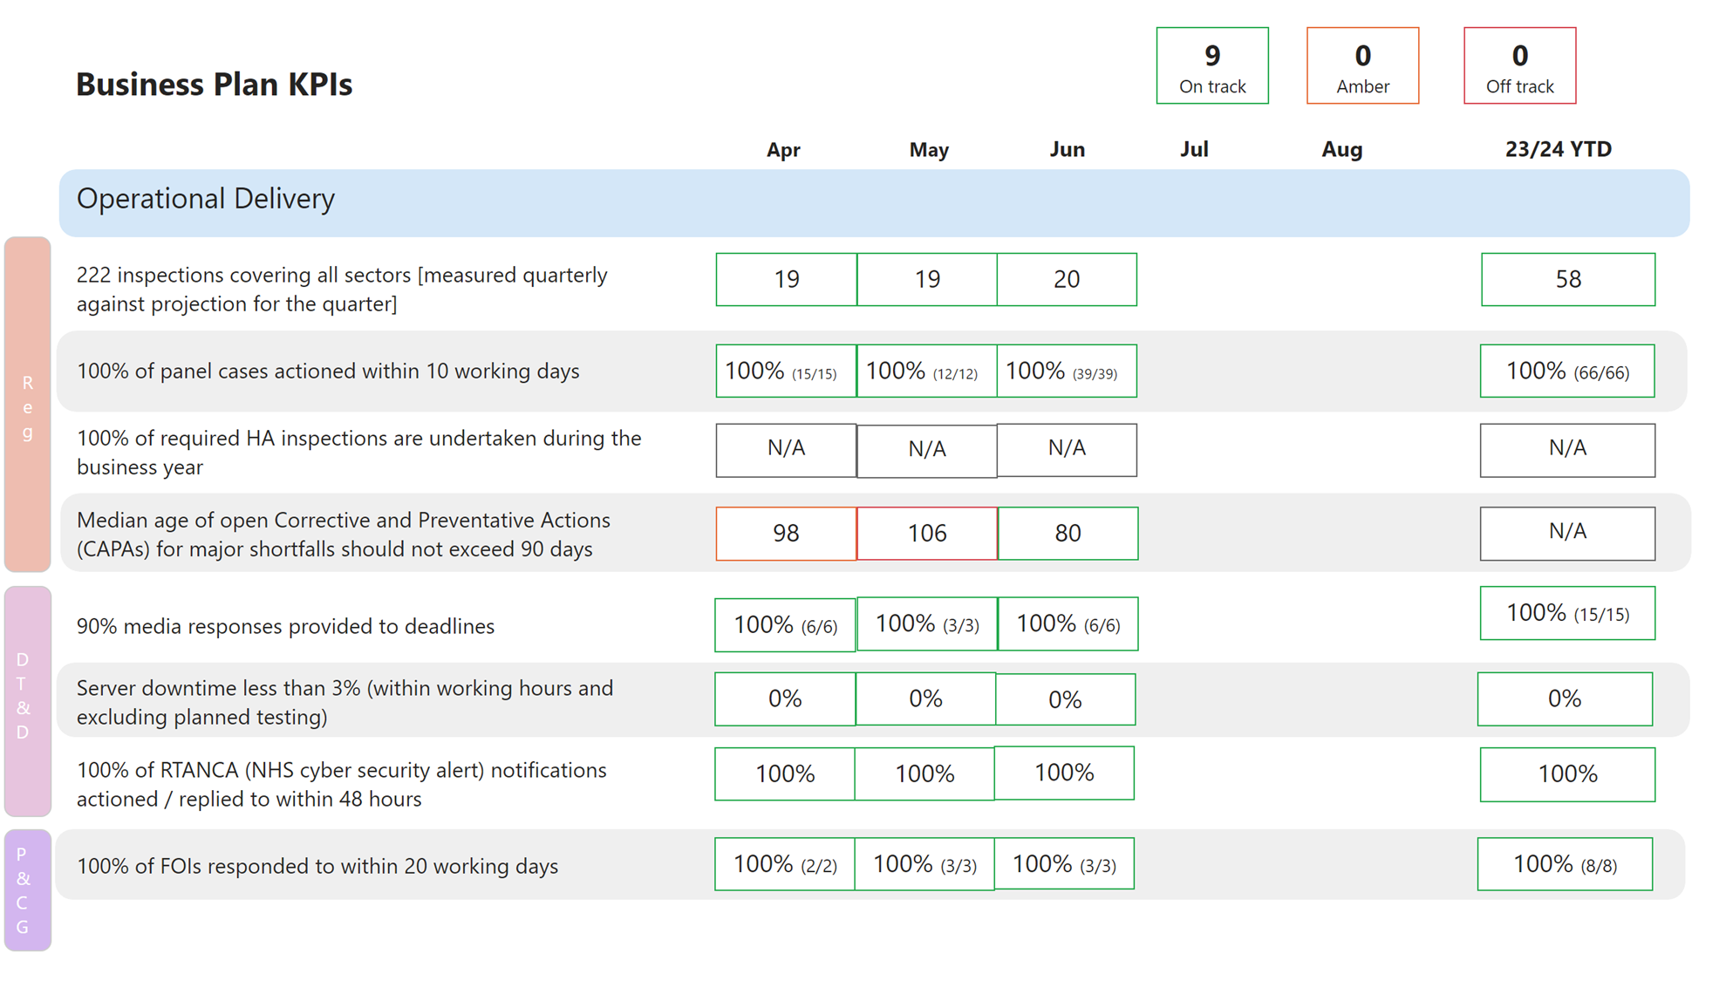

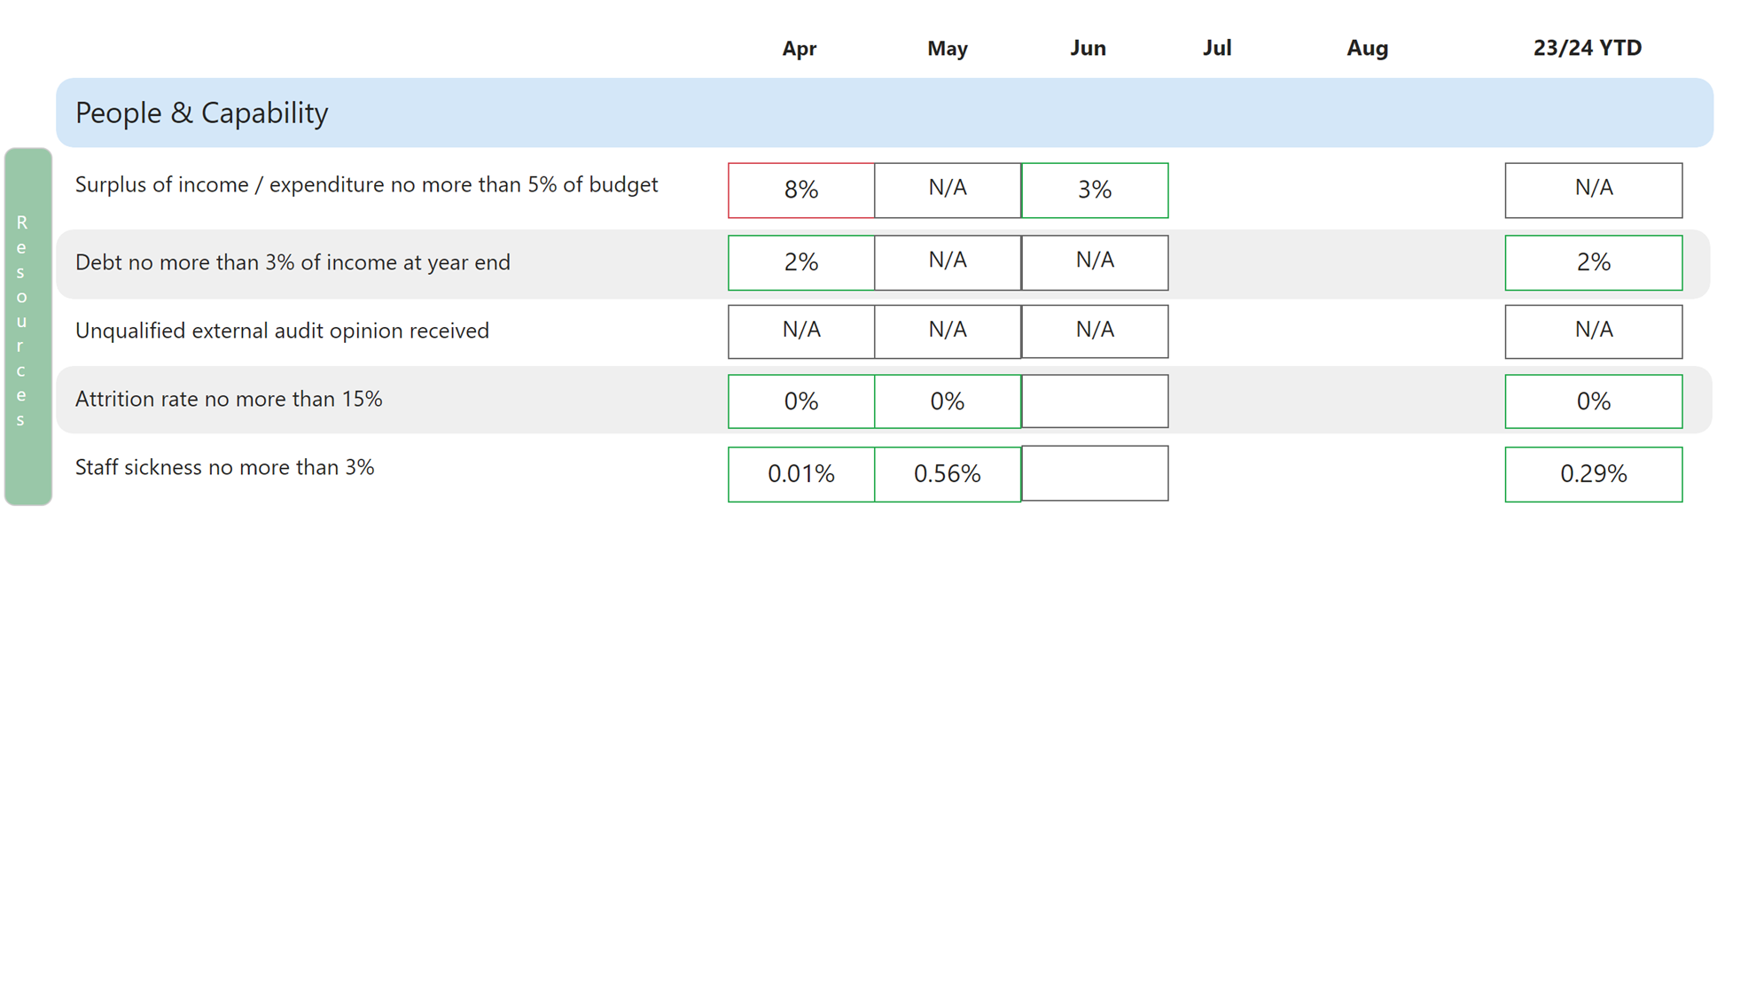

**Change Activities**

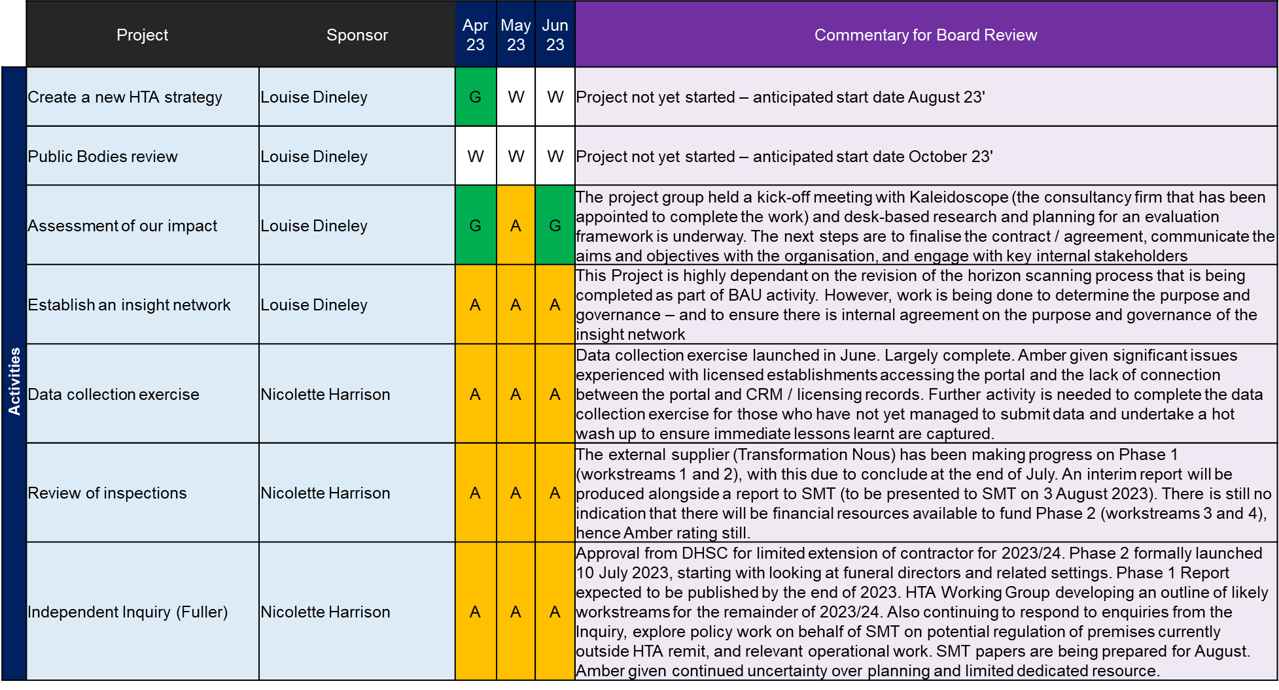

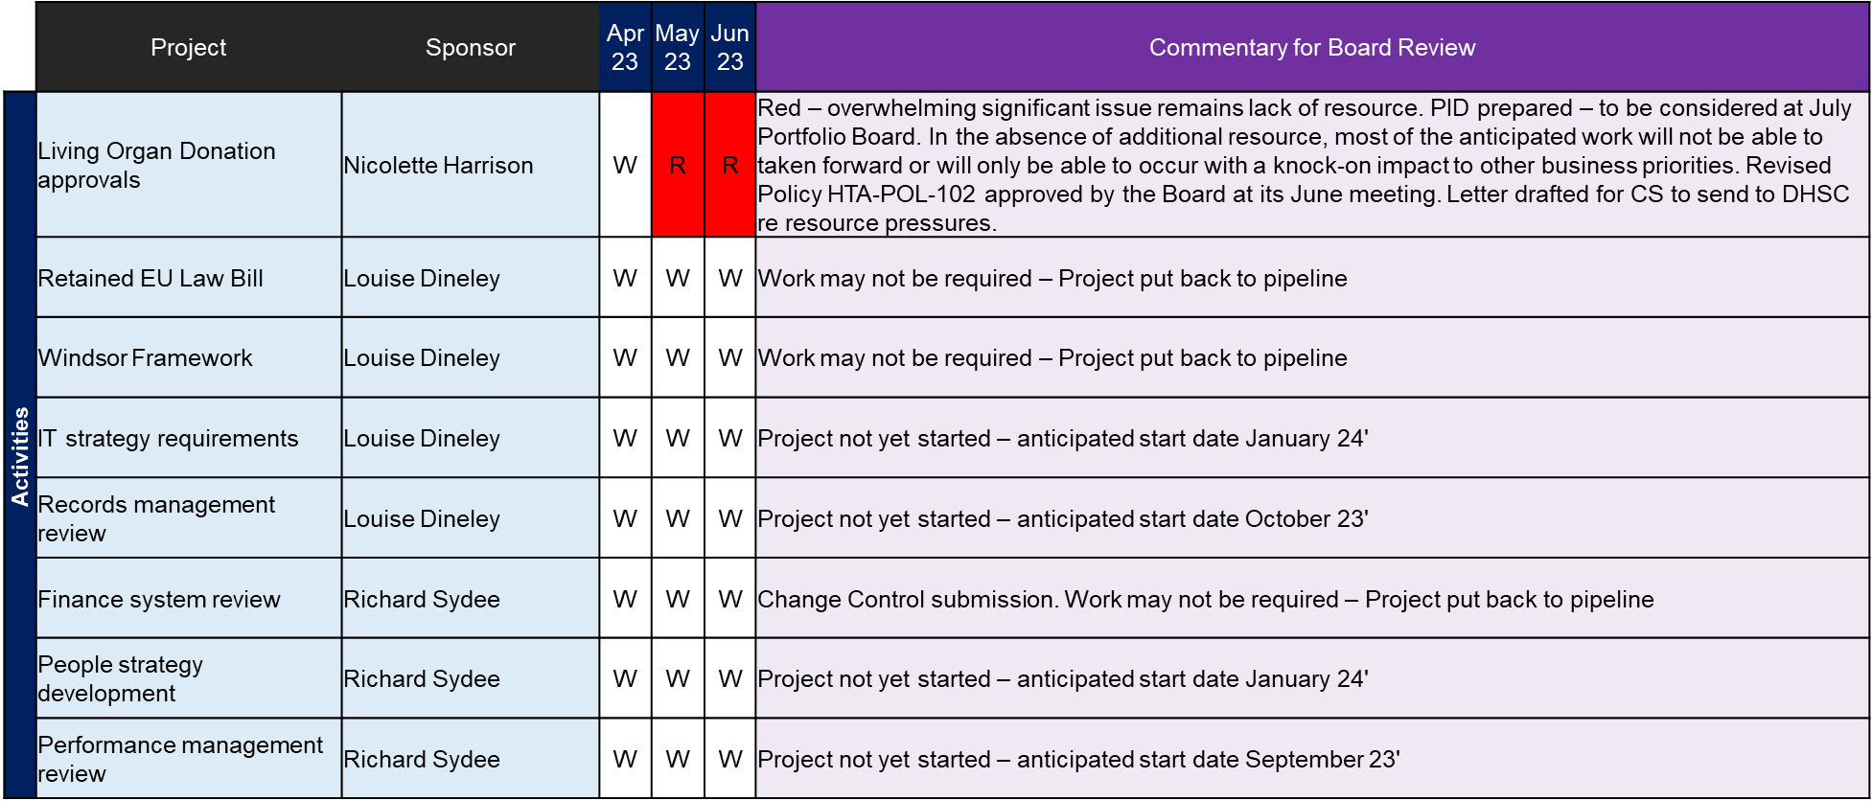

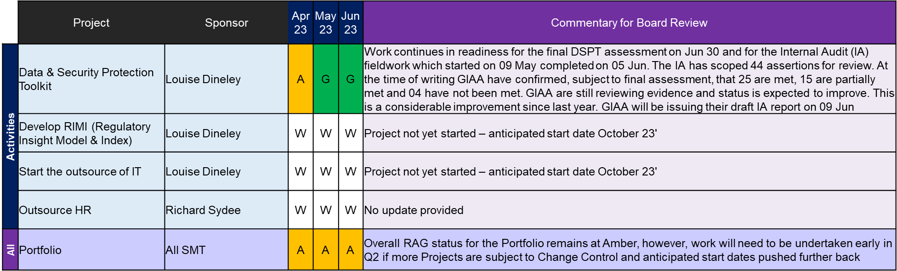

**Annex B – Quarterly Board Data Overview, 23/24 Quarter 2 Latest Position**

**Core Operations**

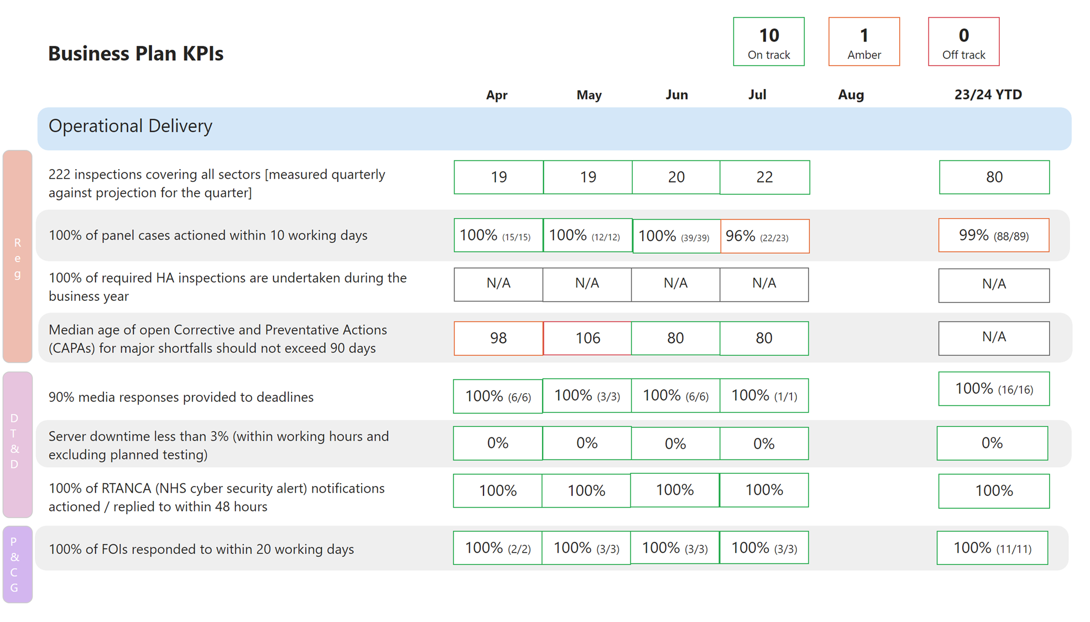

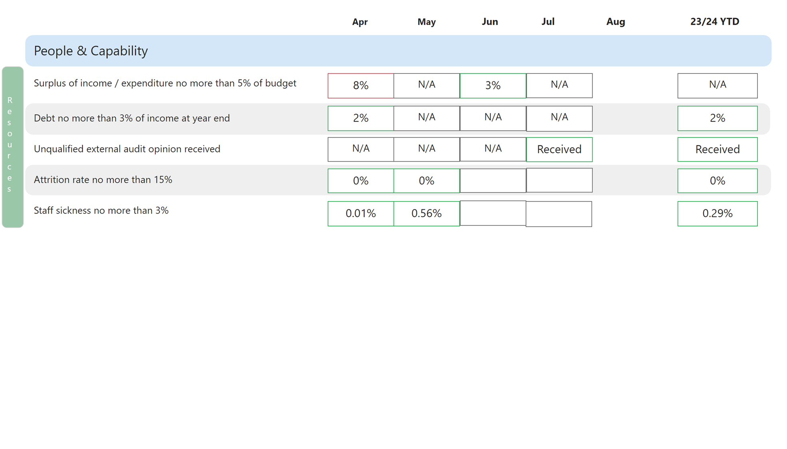

**Change Activities**

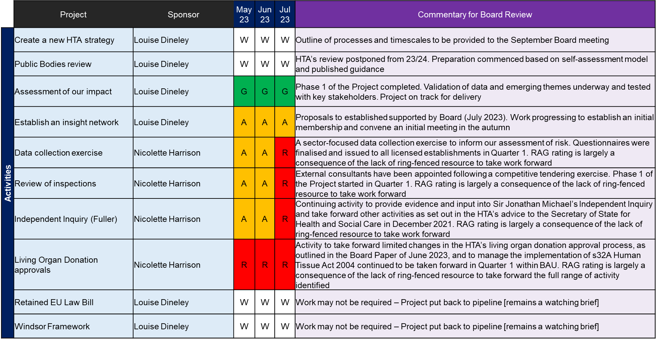

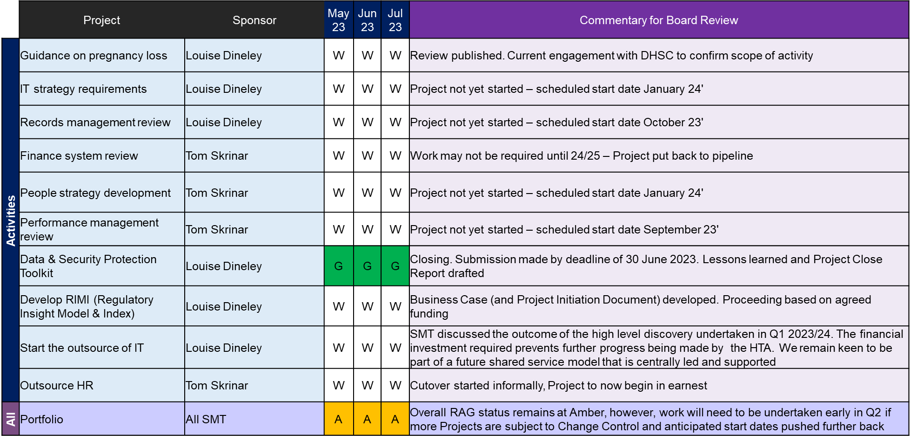

|  |  |  |  |
| --- | --- | --- | --- |
| **Red** | **Amber** | **Green** | **White** |
| * There is significant risk that the overall Activity will be delivered late or will fail to deliver everything within scope against the agreed baseline plan. | * There is a risk that one or more milestones may be late, or that the full scope will not be delivered. However, there is a good possibility of implementing mitigations to bring the plan back on track to meet the schedule and delivery as planned. | * Overall Activity is on track to be delivered against the baseline plan and there is no or minimal risk of milestones being delivered late. | * Activity not live |

**Annex C**

##### Strategic risk register 2023/24

##### Risk summary: residual risks

| **Risk area** | **Strategy link\*** | **Residual risk** | **Risk owner** | **Status** | **Tolerance** | **Trend\*\*** |
| --- | --- | --- | --- | --- | --- | --- |
| R1: Failure to regulate appropriately | Delivery (a-d & f) and Development (a-d) objectives | **9 – Medium** | Director of Regulation | Below tolerance | **10** | òóóó |
| R2: Failure to manage an incident | Delivery, Development and Deployment objectives | **6 - Medium** | Director of Regulation | At  tolerance | **6** | óóóó |
| R3: Failure to manage expectations of regulation | Delivery e) and Development c) | **9 - Medium** | Director of Data, Technology & Development | At tolerance | **9** | óóóó |
| R4: Failure to utilise our staff capabilities effectively | Delivery, Development and Deployment (a, c, and d) | **16 - High** | Director of Resources | At tolerance | **9** | ñóòó |
| R5: Insufficient or ineffective management of financial resources | Deployment (b) objective | **9 - Medium** | Director of Resources | Above tolerance | **3** | óóóñ |
| R6: Failure to take advantage of opportunities that allow the HTA to be an efficient regulator responsive to change and aware of the impact that it has on the sectors and activities that it regulates to ensure public trust and confidence is maintained | Development (a-d) objectives | **9 - Medium** | Director of Data, Technology and Development | At tolerance | **9** | óóóò |
| R7 Failure to optimise the safe use of existing and emerging digital data and technology | Delivery (a-e), Development (a-d)  Deployment (a, c and d) | **12 - High** | Director of Data, Technology and Development | Above tolerance | **9** | óñóó |
| R8: Failure to deliver the agreed Business Plan | Delivery, Development and Deployment objectives | **12 - High** | Deputy Director of Performance and Corporate Governance | Above tolerance | **6** | óñ |

* Strategic objectives 2021-2024:

** This column tracks the four most recent reviews by SMT (Senior Management Team) (e.g.,ñÛòÛ).

## R1: There is a risk that we fail to regulate in a manner that maintains public safety and confidence and is appropriate.

|  |  |  |  |  |  |
| --- | --- | --- | --- | --- | --- |
| **Inherent risk level:** | | | **Residual risk level:** | | |
| Likelihood | Impact | Inherent risk | **Likelihood** | **Impact** | **Residual risk** |
| 3 | 5 | 15 - High | **3** | **3** | **9 - Medium** |
| **Tolerance threshold:** | | | | | **10 - Medium** |

|  |
| --- |
| **Commentary** |
| **Below tolerance.**  We believe we have a sound regulatory framework, which we continue to evolve in response to emerging risks and our own desire to continue to be risk-based, proportionate and data-driven.  Recent internal audits gave moderate assurance on Living Organ Donation approvals (March 2023) and the Effectiveness of the Inspection Process (April 2022).  The HTA has further refined its approach to living organ donation assessment in recognition of emerging risk and continues to play a significant role in multi-agency efforts to address risks related to some overseas travel for organ transplantation following the introduction of new offences under the Human Tissue Act in July 2022. An update was provided to the Board in June 2023, who approved our updated Living Organ Donation approvals policy.  The HTA is continuing to evolve our approach to inspection, one of our core regulatory tools, introducing Evaluated Self-Assessments (ESAs) this year. We are on track with the further increased target for inspection coverage of 222 inspections for 2023/24 on existing licences, in addition to full assessment of all new licence applications.  Inspection is only part of our regulatory toolkit, and we continue to manage and respond to incident reports, whistleblowing / informant information and provide advice and guidance to our sectors and the public. We also have an active programme of engagement with our regulated sectors and other relevant stakeholders. We have also recently undertaken a risk-focused data collection exercise across all licensed establishments.  We continue to be transparent about our regulatory activities and outcomes through various means, including publication of inspection reports, performance data and other data, such as the quarterly summaries of closed incidents reported to us. These provide public assurance on our delivery of core regulatory functions. We also provide suitable public comment on matters within our remit where relevant, including on our website and through engagement with media.  We continue to support Sir Jonathan Michael’s Independent Investigation into offending at a hospital mortuary and are pursuing a programme of related activity, including with wider sector stakeholders, as set out in our published advice to the Secretary of State in December 2021.  SMT believes this risk is just below tolerance. |

## R2: There is a risk that we will be unable to manage the lifecycle of a significant incident, event or issue impacting on the delivery of HTA objectives.

|  |  |  |  |  |  |
| --- | --- | --- | --- | --- | --- |
| **Inherent risk level:** | | | **Residual risk level:** | | |
| Likelihood | Impact | Inherent risk | **Likelihood** | **Impact** | **Residual risk** |
| 4 | 5 | 20 – Very high | **2** | **3** | **6 – Medium** |
| **Tolerance threshold:** | | | | | **6 – Medium** |

|  |
| --- |
| **Commentary** |
| **At tolerance.**  This risk concerns our ability to respond to and manage incidents, irrespective of their nature or cause whilst maintaining delivery of core business objectives. It is not confined to incidents relating to our regulatory remit.  We have rewritten our Critical Incident Response Plan and tested it during 2022/23 with specialist consultancy and completed a similar exercise for our Business Continuity Plan in Q1 2023/24. These have provided assurance on the effectiveness of our plans and our ability to use them. We will review both procedures annually and undertake a test with all staff each January to ensure that we are sufficiently prepared to manage incidents as they arise.  In addition, those plans have also been deployed and found effective in a number of differential circumstances over the past few years, including managing the impact of the pandemic and related restrictions, managing the potential impacts of EU Exit following the end of the Transition Period and in our mobilisation planning in preparation for the trial of Fuller.  Having increased the risk scoring in July 2021, in anticipation of the prospective Fuller trial, we now believe that the likelihood of this risk materialising has reduced. Sir Jonathan Michael’s Independent Inquiry into the circumstances of Fuller’s offending and any related wider concerns about settings in which the deceased are managed still continues and is expected to report on Phase 1 during 2023 and on Phase 2 in 2024. Given there are currently other criminal proceedings concerning unrelated matters within our broader remit, we believe there is still the potential for significant impact of an incident on our corporate objectives, either from those causes or others of which we may still be unaware.  Hence SMT considers the residual risk remains at the tolerance level. |

## R3: There is a risk that we will fail to manage public and professional expectations of human tissue regulation stemming from limitations in current legislation, misperception of HTA regulatory reach and innovations in the use of human tissues and cells.

|  |  |  |  |  |  |
| --- | --- | --- | --- | --- | --- |
| **Inherent risk level:** | | | **Residual risk level:** | | |
| Likelihood | Impact | Inherent risk | **Likelihood** | **Impact** | **Residual risk** |
| 3 | 4 | 12 - High | **3** | **3** | **9 – Medium** |
| **Tolerance threshold:** | | | | | **9 – Medium** |

|  |
| --- |
| **Commentary– to be updated based on agreement of the risk** |
| **At tolerance.**  The HTA has successfully completed year 1 of the delivery of its revised Communications & Engagement Strategy. Progress on embedding the strategy and new channels and tools that have been adopted was reported to the Board at the end of June.  The strategy is underpinned by a commitment for being more proactive and open in our communication and engagement with professionals and the public. In the last quarter we have continued to embed sector-based forums and roundtables, strengthen social media presence, and proactively respond to media enquiries. The work of the Comms & Engagement Team has contributed to the generation of positive headlines in relation to stories such as the first uterine transplant, press statements on successful prosecutions and strengthened partnerships with DHSC, ALBs and license holders.  In addition to the strategy there has been a significant focus in Q1 & 2 to ensure any published material including the experience of using the HTA website meets accessibility standards. The HTA’s website has been independently audited and identified some further opportunities to improve accessibility. A revised accessibility statement has been approved and published.  The HTA remains committed to improving the accessibility of all published information.  The HTA acknowledges that to continue to regulate effectively it is important that it understand the impact of its activities whilst at the same time continuing to be responsive to innovation and growth across Life Sciences. The HTA is progressing work that seeks to assess the impact of the HTA as a regulator and its activities. This will culminate in a publication the aim of which will be to share insight and feedback on the regulated activities and sectors and promote public confidence in the safe use of tissues and cells.  Looking ahead at 2023/24 the HTA will be reviewing its Strategy. This will set the direction of travel for the next 3 years and potentially beyond as well as showcasing the ongoing importance of regulating the use of human tissues and cells.  SMT consider this risk to be at tolerance. |

**R4: Failure to adequately deliver the diverse, capable workforce the HTA requires or needs to fulfil its functions and objectives**

|  |  |  |  |  |  |
| --- | --- | --- | --- | --- | --- |
| **Inherent risk level:** | | | **Residual risk level:** | | |
| Likelihood | Impact | Inherent risk | **Likelihood** | **Impact** | **Residual risk** |
| 4 | 3 | 12 - High | **4** | **4** | **16 - Medium** |
| **Tolerance threshold:** | | | | | **9 – Medium** |

|  |
| --- |
| **Commentary** |
| **Above tolerance.**  We started off the 2023/34 business year with far fewer vacancies to fill that the same period last year. Churn and recruitment have returned to within expected tolerances, and we have been able to successfully fill most vacancies from the initial recruitment round.  Retention of colleagues will remain an issue, our overall package of salary and benefits remains competitive across the public sector sphere in which we operate – although headline gross pay does not always seem competitive with the NHS. Our revised approach to advertising, and the work to review our salary bands, will manage internal and external expectations around salary – although the continued absence of real terms pay progression to band maximum will likely mean that churn will remain an issue and the lack of progression within the organisation a barrier to retaining necessary internally developed skills. We must continue to acknowledge that several of our functions rely on a single individual and that unexpected departures in key roles will inevitably impact on delivery of some key outputs in the short term – this risk is further exacerbated by the current DHSC controls on the use of contingent labour.  There is a risk that the transition to outsourced shared services creates pressures on key HR operations in the short term as we transition, we will need to resource both ongoing operations and transition activities concurrently. There will also need to be careful management of areas such as corporate training and organisational development to ensure that this is not lost sight of as internal HR colleagues are required to focus more on transition and handover to CQC. In the medium term we feel the new service will provide a greater breadth of options and services available to our colleagues, as well as greater service resilience as it will be based within a large, structured HR team within CQC.  We recognise the risk of losing staff confidence in the service and will tailor communications to ensure that the process is clear to staff, including how the transition will proceed. We also recognise that we have single points of failure where individuals that hold significant amounts of organisational knowledge and understanding of HTA HR systems and processes and are engaging closely with CQC to manage any short-term risks to service continuity.  Long term absences amongst key staff and a delay in new employees starting is reflected in our residual risk scoring as we believe it impacts on our ability to deliver a capable and diverse workforce. This also is reflected in risk 8 (delivery of our business plan). There are plans in place to build in resilience across the organisation utilising staff within the Private Office function. |

## R5: There is a risk that the HTA has insufficient or ineffective management of its financial resources

|  |  |  |  |  |  |
| --- | --- | --- | --- | --- | --- |
| **Inherent risk level:** | | | **Residual risk level:** | | |
| Likelihood | Impact | Inherent risk | **Likelihood** | **Impact** | **Residual risk** |
| 4 | 5 | 20 – Very high | **3** | **3** | **9 – Medium** |
| **Tolerance threshold:** | | | | | **3 – Low** |

|  |
| --- |
| **Commentary** |
| **Above tolerance.**  Budgets for 2023/24 have been agreed and delegation letters to Directors issued. Our Grant in Aid (GIA) funding from the Department has been confirmed at previous levels and we have been provided with cover for asset purchases (Capital DEL - £30k) and depreciation and amortisation costs (Ring Fenced RDEL). Submissions were made to Ministers regarding options to generate reductions in GIA delegations for 2023/24 and 2024/25 and this has been confirmed wef 1st April 2024 but with no reductions in the 2023/24 GIA.  The budget for 2023/24 has absorbed several pressures, including additional costs related to the support of the Independent Inquiry. A number of work programmes at the start of the year were part funded with the expectation that underspends will emerge through staff churn, and that licence fee income will again significantly overshoot our estimate.  We are currently forecasting an overspend as the underspend through staff churn or the expected increase in our income has not materialised. This will need to be carefully monitored and managed through the rest of the financial year and we could require decisions to pause some programmed work to ensure that the HTA does not exceed its spending controls, though we are not actively holding back planned spend at this stage.  Requests to the Department have been made for additional GIA to fund the support to the Fuller Inquiry where we had previously thought we could absorb this cost, though this additional funding cannot be relied on, or could potentially be approved later in the year when we would have less opportunity to plan for and realise the benefits from it.  The departure of the incumbent Director of Finance & Resources has led to additional workload pressures on the team during the two-month period prior to the new Director’s arrival. This has been managed very well but will continue whilst the new Director embeds and focuses on prioritised issues. |

## R6: Failure to take advantage of opportunities that allow the HTA to be an efficient regulator responsive to change and aware of the impact that it has on the sectors and activities that it regulates to ensure public trust and confidence is maintained.

|  |  |  |  |  |  |
| --- | --- | --- | --- | --- | --- |
| **Inherent risk level:** | | | **Residual risk level:** | | |
| Likelihood | Impact | Inherent risk | **Likelihood** | **Impact** | **Residual risk** |
| 4 | 3 | 12 - High | **3** | **3** | **9 – Medium** |
| **Tolerance threshold:** | | | | | **9 – Medium** |

|  |
| --- |
| **Commentary** |
| **At tolerance.**  This risk has been updated and redefined for 2023/24 to reflect a central priority supporting efficiency and reform.  As with risk 3 the HTA has progressed and delivered several projects in the post pandemic period reflecting changes in the way that it works and to ensure it remains responsive to opportunities for working differently. The 2023/24 Business Plan includes a number of projects that will follow this direction of travel. Activities under risk 3 and this risk 6 coalesce to support the HTA’s vision and mission.  It is anticipated that updates on the risk will reflect the progress of identified projects and align with updates and actions identified across other risks specifically risks 3, 4, 5 & 7. This alignment is critical. As in previous years, the availability of resources (people and financial) have been significant factors in setting the pace and appetite for change.  A further consideration and alignment opportunity for the HTA will be with the myriad of central initiatives and programmes that take advantage of economies of scale and consolidation of improvement opportunities and skills.  Since the start of 2023/24 there have been a range of different activities including independent reviews such as the McLean Review and the Review of Pregnancy Loss that have led us to consider and work with partners on opportunities for change and improvement in regulation. |

## R7: Failure to optimise the safe use of existing and emerging digital data and technology

|  |  |  |  |  |  |
| --- | --- | --- | --- | --- | --- |
| **Inherent risk level:** | | | **Residual risk level:** | | |
| Likelihood | Impact | Inherent risk | **Likelihood** | **Impact** | **Residual risk** |
| 4 | 4 | 16 – High | **4** | **3** | **12 – High** |
| **Tolerance threshold:** | | | | | **9 – Medium** |

|  |
| --- |
| **Commentary** |
| **Above tolerance.**  Over the last 2 years the HTA has been progressing with the planned development of its digital data and technology (systems and architecture) as part of the Development Programme. The planned development had been incremental based on available resources and aimed to future proof business needs.  Two projects were identified in 2022/23. These were (1) the adoption of an IT Shared Services model and (2) stage 2 development of the Regulatory Insight Model and Index. As identified under risk 6 progress has not been possible due to resource constraints.  The HTA’s IT function has been an area of consistent pressure for several years. As part of the 2023/24 business plan there has been confirmation of a substantive Head of IT position. The identified resource is positive however given the competitive IT recruitment market, successful recruitment and retention is an ongoing risk.  A revised recruitment plan and approach has been identified and was shared with RemCo.  As with risk 6, the HTA’s ability to optimise the use of existing and emerging data, digital and technology opportunities is largely reliant on investment and resource. There is a clear vision and confidence in what could be delivered although the reliance on single roles in this area and wider ambitions means that substantive recruited resource is at capacity.  At the start of 2023/24 this risk is above tolerance. |

## R8: Failure to deliver the agreed Business Plan

|  |  |  |  |  |  |
| --- | --- | --- | --- | --- | --- |
| **Inherent risk level:** | | | **Residual risk level:** | | |
| Likelihood | Impact | Inherent risk | **Likelihood** | **Impact** | **Residual risk** |
| 3 | 4 | 12 – High | **4** | **3** | 12 – High |
| **Tolerance threshold:** | | | | | **6 – Medium** |

|  |
| --- |
| **Commentary** |
| **Above tolerance.**  The 2023/24 Business Plan has been created through a codesign process involving Board and staff such that we are confident that it is both challenging but achievable.  We operate a formal Portfolio Management approach to the management of our Business Plan delivery, with explicit processes and best practice outputs tracking progress and scrutiny at Business Delivery Team (middle management) fortnightly, Portfolio SMT (senior management) monthly and Board quarterly.  Portfolio Management allows us to be flexible in-year so that as we are reviewing our performance, we can also consider additional requests and pressures as they arise, refining our Business Plan through change control and redeploying resources as needed.  To date, progress to deliver the 2023/24 Business Plan has been noted as acceptable, albeit that several indicative Project start dates have been adjusted through change control to later in the year.  This risk is currently considered above tolerance. We have an ambitious Business Plan and the Q1 financial outturn is such that it is unlikely that we will be able to progress all the items that we have identified for delivery (see Risk 5).  We are also experiencing staffing issues within key technical positions, and this is impacting our capacity to deliver key work (see Risk 4). The combined effect means that we may have to scale back some of our ambitions in-year. |

## Reviews and revisions

**(25/04/23) SMT review April/May 2023**

At its meeting in April, the SMT reviewed each of its Strategic risks. There was discussion around whether we have sufficient breadth of risk and whether a risk that focused on data and digital was needed in addition to the risk around delivery of the Development programme. It was agreed that each risk owner should review their risk descriptions and in addition create 2 new risks around business plan delivery and strategy – strategic direction. A risk focussing on compliance is to be discussed at the next meeting.

**(23/05/23) SMT review April/May 2023**

At its May meeting, the SMT agreed the re-wording of risk 2 and a reduction in the likelihood. Risk 4 has been amended to reflect not just recruitment and vacancies but to reflect risks around the workforce.

Risk 5 has been re-cast, however, SMT felt that the tolerance level was too low and that this will be brought to ARAC in June to discuss a recommendation to the Board to increase it to 4.

Risk 6 has been split into two (risk 6 and risk 8) to reflect risks around our strategy and our business planning.

There is a final risk (risk 9) which requires further discussion. The risk update paper presented to ARAC in June will refer to this risk and the need for discussion.

**(22/08/23) SMT review August 2023**

SMT reviewed each of their risks. Ratings were amended for the following risks:

* Risk 4 – residual risk increased to a rating of ‘high’. Whilst we are experiencing almost full complement of staff, the SMT recognise that there are additional pressures created from absences, staff leave. A key function is currently understaffed which in the short term may impact on other areas of the business.
* Risk 5 – has been uprated due to the challenges currently being faced around funding for key projects and pressures that have arisen from changes to the Living Organ Donation (s32). There are mitigations which involve reaching out to the Department, however until feedback is received, the rag status will remain.
* Risk 8 – impacted by risks 4 and 5 as detailed in the commentaries above.

**Strategic Aims/approach**

**Criteria for inclusion of risks**

* Whether the risk results in a potentially serious impact on delivery of the HTA’s strategy or purpose.
* Whether it is possible for the HTA to do anything to control the risk (so external risks such as weather events are not included).

### Rank

The risk summary is arranged in risk order.

### Risk scoring system

We use the five-point rating system when assigning a rating to the likelihood and impact of individual risks:

Likelihood:1=Rare 2=Unlikely 3=Possible 4=Likely 5=Almost certain

Impact:1=Very low 2=Low 3=Medium 4=High 5=Very High

|  |  |  |  |  |  |  |
| --- | --- | --- | --- | --- | --- | --- |
| **IMPACT** | **Risk Scoring Matrix** | | | | | |
| **5. Very High** | 5  Medium | 10  Medium | 15  High | 20  Very High | 25  Very High |
| **4. High** | 4  Low | 8  Medium | 12  High | 16  High | 20  Very High |
| **3. Medium** | 3  Low | 6  Medium | 9  Medium | 12  High | 15  High |
| **2. Low** | 2  Very Low | 4  Low | 6  Medium | 8  Medium | 10  Medium |
| **1.Very Low** | 1  Very Low | 2  Very Low | 3  Low | 4  Low | 5  Medium |
| **Likelihood** | | | | | | |
| **Risk score = Impact x Likelihood** | | **1.Rare**  **(≤3%)** | **2.Unlikely**  **(3%-10%)** | **3.Possible**  **(10%-50%)** | **4.Likely**  **(50%-90%)** | **5.Almost certain**  **(≥90%)** |

### Risk appetite and tolerance

Risk appetite and tolerance are two different but related terms. We define risk appetite as the willingness of the HTA to take risk. As a regulator, our risk appetite will be naturally conservative and for most of our history this has been low. Risk appetite is a general statement of the organisation’s overall attitude to risk and is unlikely to change unless the organisation’s role or environment changes dramatically.

Risk tolerances are the boundaries for risk taking. The risk appetite statement informs the development of risk tolerances for the HTA and provides guidance on how the risk appetite statement is to be applied in everyday business activities and decisions.

### Assessing inherent risk

Inherent risk is usually defined as ‘the exposure arising from a specific risk before any action has been taken to manage it.’ This can be taken to mean ‘if no controls at all are in place.’ However, in reality the very existence of an organisational infrastructure and associated general functions, systems and processes introduces some element of control, even if no other mitigating action were ever taken, and even with no risks in mind. Therefore, for our estimation of inherent risk to be meaningful, we define inherent risk as:

*‘The exposure arising from a specific risk before any additional action has been taken to manage it, over and above pre-existing ongoing organisational systems and processes.*’

### Contingency actions

###### When putting mitigations in place to ensure that the risk stays within the established tolerance threshold, the organisation must achieve balance between the costs and resources involved in limiting the risk, compared to the cost of the risk translating into an issue. In some circumstances it may be possible to have contingency plans in case mitigations fail, or, if a risk goes over tolerance, it may be necessary to consider additional controls.

###### When a risk exceeds its tolerance threshold, or when the risk translates into a live issue, we will discuss and agree further mitigations to be taken in the form of an action plan. This should be done at the relevant managerial level and may be escalated if appropriate.