**Human Tissue Authority**

**Board Meeting Conducted in Public**

Paper reference: HTA 12/23

Agenda item: 5

Author: CEO and Senior Management Team

HTA Performance Report

Purpose of paper

1. This paper informs the Board of the HTA’s performance in Quarter 4 (Q4) against our objectives and operational delivery targets and also provides cumulative overall performance against targets for the year, 2022/23.
2. In addition, it provides an early indication of the initial performance against the new performance indicators for 2023/24.

Action required

1. The HTA Board is asked to note and comment on the performance recorded and the context provided.

Regulation

1. **Annex A** provides a summary of the Key Performance Indicators (KPIs) and two Performance Indicators (PIs) for Quarter 4 of 2022/23, including the year-end totals. Most of these relate to the Regulation Directorate but Enquiries and Freedom of Information Act (FoI) requests can arise in any area of the business.
2. The headline KPI for 2022/23 of the significantly increased target of 210 inspections was met.
3. The measure of inspections changed from 2022/23 to exclude inspections on new licence applications. Delivering 253 inspections in total (210 inspections on existing licences plus 42 on new licence assessments) was a significant operational achievement, facilitated by the wider adoption of more proportionate, innovative and efficient approaches, which will be expanded on during 2023/24.
4. Unannounced inspections, in response to specific regulatory concerns, have continued to play a part in our inspection programme, with one unannounced inspection having been carried out in the Human Application sector.
5. Other performance indicators for Quarter 4 of 2022/23 and year-end show a mixed picture. Whilst, most of the year-end performance is close to target, the KPI data on the processing at least 90% of complete new licence applications shows this measure as notably missed. The Quarter 4 performance shows this at 50% (4 out of 8) and the year-end outturn was 60% (19 out of 32 cases). The main issue is that applications are marked as ‘complete’ when all relevant sections of the application form have been completed. This does not necessarily mean that a licence can be issued as compliance with standards still needs to be assessed. Therefore, even ‘complete’ applications may not be in a position to be offered a licence for some time.
6. The same issue arises with the licence variation request KPI. We have explored options to change the point at which we ‘start the clock’ and / or ‘stop the clock’, to allow time for relevant regulatory activity to ensure suitable compliance with standards before issuing a licence or licence variation. A system change to facilitate this is unlikely to be implemented before the next reporting year.

1. The HTA reviewed and updated its published guidance to the Anatomy sector licensing standards in Quarter 4. This entailed external engagement and feedback from stakeholders.

1. The HTA assessed several complex Living Organ Donation cases during Quarter 4. Decisions were made in all cases, with one case declined.
2. The HTA has actively engaged with the living organ donation sector, including NHS Blood and Transplant, to discuss recommendations to support the development and sustainability of living donor liver transplantation in the UK.
3. The Head of Regulation for ODT gave evidence on the HTA’s living organ donation approval process at the recent trial for people trafficking for the purpose of organ donation. (Under the Modern Slavery Act 2015, people trafficking for the purpose of organ donation is one definition of exploitation amounting to modern slavery). The defendants were convicted under the Modern Slavery Act; the first convictions of this kind in the UK.
4. On 1 July 2022, amendments to the Human Tissue Act 2004 and the Human Tissue (Scotland) Act 2004 came into force, inserting a new section 32A and 20A into each Act respectively. This extends the offences relating to commercial dealings in organ transplantation so that they now apply outside of the United Kingdom in certain circumstances. The HTA has been leading on developing and refining the process for referring suspected cases and this work continues.
5. During Quarter 4, the HTA referred 2 cases of potential Human Tissue Act offences relating to living organ donation to the police for further investigation.
6. During Quarter 4 a living organ donation that had been referred to the HTA for consideration took place before HTA approval had been given. Whilst the HTA approved the transplant retrospectively, the facts and circumstances that led to the hospital undertaking the transplant prior to obtaining HTA approval is being investigated by the HTA and the hospital concerned.
7. The HTA was involved throughout Quarter 4 in work to support a wider regulatory response to contamination issues with certain perfusion fluids. This required complex multi-agency activity, involving the Medicines & Healthcare products Regulatory Agency (MHRA) and others. The HTA issued a Regulatory Alert and a Regulatory Update and continues to maintain a watching brief.

1. Pressures on mortuary capacity last winter led to an increase in enquiries and in incidents reported to the HTA. One emergency mortuary licence was issued at short notice and several short-notice and urgent responsive regulatory actions were undertaken. A Regulatory Alert was issued on 10 January 2023 to provide advice and guidance on managing mortuary capacity issues. This topic was also discussed at the Post-Mortem Sector stakeholder engagement forum on 6 February 2023.
2. **Finance**

The table below is the summary position as at the 31 March 2023 (our financial year end). We have ended the year with a surplus over budget of £438k, below is the breakdown by exception of each component of this surplus.

**Table 1: Summary income and Expenditure**

|  |  |  |  |  |
| --- | --- | --- | --- | --- |
|  | **Actuals** | **Budget** | **Variance**  **£** | **Variance**  **%** |
| **Income** |  |  |  |  |
| **Grant-in-aid** | **814** | **966** | **(152)** | **(15.73%)** |
| Non-cash | 78 | 78 | - | - |
| Licence Fees | 4,285 | 4,146 | 139 | 3.35% |
| Other Income | 203 | 191 | 12 | 6.28% |
| **Total Income** | **5,380** | **5,381** | **(1)** | **(0.02%)** |
| **Expenditure** |  |  |  |  |
| Salaries and Wages | 3,739 | 3,882 | (143) | (3.7%) |
| Other staff costs | 202 | 282 | (80) | (28.4%) |
| Other operating costs | 137 | 180 | (43) | (23.9%) |
| IT & Telecoms | 344 | 370 | (26) | (6.9%) |
| Legal / Professional | 151 | 109 | 42 | 38.5% |
| Consultancy | 74 | 10 | 64 | 644.3% |
| Accommodation | 173 | 270 | (97) | 35.9% |
| Non-cash | 122 | 78 | 44 | 55.1% |
| Contingency | 0 | 200 | (200) | - |
| **Total costs** | **4,942** | **5,381** | **(439)** | **(8.15%)** |
| **Net income** | **438** | **0** | **438** |  |

**Income**

1. Our income has ended the year on budget, despite the reduction in our grant in aid which was returned to the Department of Health and Social Care as part of the reform and efficiencies activity. The short-fall being made up from an increase in income from licence fees across all sectors except for the Public Display and Research sectors where there was a very small drop of less than £2k in each case.

**Expenditure**

1. We have underspent by £439k against budget. Areas of significant underspend are detailed below:
   * Salaries and wages - £143k, in particular staff salaries were underspent by £169k due to turnover which is offset by an overspend on contingent labour of £64k. The use of temporary staff to cover key roles that have taken time to fill in a volatile market. The balance of £38k relates to Board Members where we are carrying at least 4 vacancies which we expect to fill in the coming months.
   * Other staff costs - £80k underspent is in part due to reduced spend against training (£51k) correlates to the increased workload across the business. The second element is our travel and subsistence costs which are also down against budget by £23k.
   * Legal and Professional costs are over budget by £42k. This is represented by a significant increase in legal advice sought across several areas of work being conducted. Professional fees are on budget.
   * Consultancy costs ended the year overspent by £64k. The majority of the spend relates to the Fuller Inquiry which was previously funded but these funds were returned via our grant in aid. Additional consultancy spend not budgeted for related to changes required to the finance system which totalled £5k.
   * Accommodation costs are £97k below budget. This is a notional variance that has arisen due to changes in how we account for our rent/lease of 2 Redman Place. From 1 April 2022, the HTA has an asset on its balance sheet which represents the lease of space with 2RP. At the end of the year, our rent payments are removed from the Income and Expenditure

Account and transferred to the Balance Sheet thus creating an underspend. It may be that going forward, we reflect this in future budget setting.

* + Non-cash cost overspend, relates to the inclusion of the lease and its subsequent depreciation and finance cost (interest).
  + The budgeted contingency of £200k was set aside for other pieces of work which were delayed some in part due to the requirement for business cases in adherence to Cabinet Office controls and enhanced DHSC controls.

**Outturn**

1. Subject to the finalisation of our year end audit, the current underspend is not expected to change significantly.

**Other key performance indicators**

**Debtors**

1. Outstanding debt from licensing activities is provided below.

|  |  |  |  |
| --- | --- | --- | --- |
| Sector | Number of establishments | Value of debt  £ | % |
| NHS | 7 | £33,779 | 30% |
| Government Bodies[1] | 1 | £4,141 | 3% |
| Non-Government Bodies[2] | 16 | £75,756 | 67% |
| Total | **24** | **£113,676** | **100** |

1. Of the 7 NHS establishments, 3 (£19k) relate to the 2020/21 financial year, this is a significant reduction; of the 16 Non-Government Bodies, 1 (£7k) relates to 2020/21 financial year, 3 (£26k) to 2021/22 and 12 (£42k) to the year just ended – 2022/23.
2. There has been a significant push in debt collection this year and the end position is a positive one. We continue to chase those that have been outstanding since 2021/22.

**Financial Risks and Mitigations**

1. As at 31 March 2023, our strategic finance risk was rated ‘low’ but above tolerance. This was an accepted risk with a review of this tolerance level undertaken in Q1 of 2023/24 and a request for the Audit, Risk & Assurance Committee (ARAC) to recommend to the Board that the level to be increased from 3 to 4. This was accepted by ARAC on 8 June.

**Human Resources**

1. Due diligence with CQC has continued over the past quarter in a positive manner. A paper has been submitted to SMT with the detail of the proposal. Subject to final approval in early July from the Board of CQC, the plan is to transition services from July starting with the recruitment process. CQC are developing a pack for HTA that will inform HTA Managers and employees of the new process going forward. A communications plan will be developed for HTA staff to ensure clarity. The current HR team will support this transition with further due diligence needed with their Learning and Development and Academy teams in Q2. There is a high-level plan that both organisations are working towards.
2. There are currently 6 vacancies and it should be noted that the volume of applications has increased significantly. The level of interest is encouraging, for example, the Corporate Services Officer role has received more than 100 applications.
3. The last all staff away day continued our organisational development (OD) work with leadership values now added to the framework. This will be agreed at SMT and fed back to the employees at the next all staff away day. Moving forward, our OD work is now focusing on Team Effectiveness and Team Based Working, with some individual team work to further embed the SDI (Strength Deployment Inventory) tool within the organisation.
4. The pay proposal has been agreed in principle and is now with the Department for consideration. This proposal addresses several historical issues that the HTA has faced. This proposal should be welcome news to HTA employees. The cost-of-living payment announced by the Government in early June is being progressed with a collective submission for all DHSC ALBs to be submitted to the Minister.
5. A pulse survey has been conducted, the results of which are broadly very positive with a few factors to drill down into. These findings were shared with colleagues at the all staff day on 15 June.

**Digital, Data and Technology**

1. The Data Security and Protection Toolkit (DSPT) is an online self-assessment tool maintained by the NHS that allows organisations to measure their performance against the national data guardian’s 10 data security standards. These standards are broken down into 120 assertions that focus on the area where compliance needs to be demonstrated.
2. The HTA is required to complete the DSPT assessment because we have access to NHS patient data and systems. We are required to provide assurance that we are practising good data security and that personal information is handled correctly.
3. The DSPT is an annual assessment which has two distinct stages, the baseline assessment and the final assessment. The baseline assessment was completed on 28 February 2023 and the deadline for the final assessment deadline is 30 June 23. The Government Internal Audit Agency (GIAA) has conducted an independent audit to assess the HTA’s compliance against the DSPT and has selected 44 assertions at random which span across all 10 standards.
4. The fieldwork exercise stage was completed on 9 June and the auditors have provided indicative ratings based on the evidence provided and interviews with key policy and process owners. The final report will be published on 30 June.
5. The HTA heavily relies on IT equipment to complete its day-to-day tasks in all areas of the business. The HTA commits to refreshing our desktop IT equipment every 3 years. We commenced the latest refresh in April with further devices procured in June. All our latest devices are now covered under a 3-year warranty providing a cost saving on repairs.
6. We also set our standards in security within our Microsoft estate. A Microsoft secure score is a representation of the organisation's security posture. Similar organisations like HTA could typically score between the 40-55%. The HTA is and has maintained high scores of over 90% for the past year. We are currently at 93.39% and looking at ways to improve it further.

**Communications and Engagement**

35. In Q4 we held four sector-focused forums covering Post Mortem, Anatomy, Human Application and Organ Donation and Transplantation. The forums came together virtually, and feedback from attendees was positive overall. A common thread was the importance of collaboration and engagement with the sectors we regulate. A summary of the forums was published as a blog on the HTA website. The team are planning forums across all sectors for Q3 of 23/24.

1. In March 2023, several colleagues attended the NHSBT/BTS congress in Edinburgh and for the first time HTA had a modest stand. Footfall and engagement with colleagues on the stand was “steady” and provided an opportunity to engage with a range of stakeholders.
2. In Q4 the website was independently audited by GDS for accessibility. The report highlighted template issues, which impact all pages of the website and issues with PDFs on the site. The template issues have been addressed and the team is working with colleagues to look at how to make more PDFs accessible. Within the collection of PDF documents, the initial focus is on inspection reports which are documents that command the interest of both licence-holders and the wider public.
3. Communications have supported the delivery of core business, issuing one Regulatory Alert and five Regulatory Updates in 2023 so far. In addition, we have published the HTA business plan for 2023/24 and the revised Code F part one, following the introduction of deemed consent in Northern Ireland.

**Governance**

1. The Risk Summary document can be found at **Annex C** to this paper. This was reviewed by SMT on 23 May 2023 and Audit and Risk Committee on 9 June 2023.
2. During Q4, the HTA received 7 Freedom of Information (FOI) requests. All except 1 of the FOI requests received were dealt with in line with the statutory timeframe. In Q4, 1 complaint was received by the HTA.
3. The Portfolio SMT process and monthly review meeting has continued, with detailed scrutiny of our performance and reprioritisation of our activities within our available resources. As this process matures, we are continually refining our approach and are now particularly looking to increase our maturity in project management through a standardised lifecycle, best practice tools and dedicated subject-specific training sessions.
4. As previously indicated, the format of **Annex A and B** to this paper have been revised to provide the Board with a wider subset of the data that informs the monthly Portfolio SMT process. The format for 23/24 includes analysis of all KPIs across our various business areas and covers progress updates against each of our agreed projects for the year. **Annex A** to this report covers the 22/23 year-end position and **Annex B** covers the latest, early 23/24 datasets.

**Current performance position for 2023/24**

1. **Annex B** reports data from month 1 (April) of 2023/24, whilst acknowledging it is still early in the year. The Board will note that there are changes in both the content and style of presentation of KPIs, which now cover all areas of the business.

Regulation

1. For month 1 of 2023/24, one out of the four KPIs for Regulatory Delivery is off track, with the median age of open Corrective and Preventive Action (CAPA) Plans relating to major shortfalls being at 98 days, against a target of 90 days. We know which cases are leading to this excess and are satisfied that effective action is being taken on some of our most complex, and at times, multi-faceted shortfalls. (For example, some of these are cumulative major shortfalls.) These actions should enable us to bring the KPI back on track.
2. We have identified those establishments that will require an inspection in 2023/24 to fulfil our statutory obligation to inspect HA licensed premises at a frequency of no less than once every two years. Whilst only one month into the business year at the time of reporting, we are on track to undertake 72 inspections by year end.
3. Through the Portfolio Management Process and our usual business delivery management, we continue to actively monitor amber and red KPIs to identify and address underlying issues.

Other areas of note

1. The KPI around our surplus against budget is a little misleading as it is the first month of the year and licence fee invoices for the HA sector have just been issued for c£1.4m against our costs for a single month, therefore showing a significant surplus. By Quarter 2, the position will begin to balance out as more cost is incurred.
2. Early project progress across our range of different projects has been acceptable to date, albeit that several indicative start dates have been adjusted to later in the year through our change control process to give a more realistic delivery programme.

**Recommendation**

1. The HTA Board is asked to note and comment on the performance recorded and the context provided.

**Annex A – Quarterly Board Data Overview, 22/23 Year End Position**

**Core Operations**

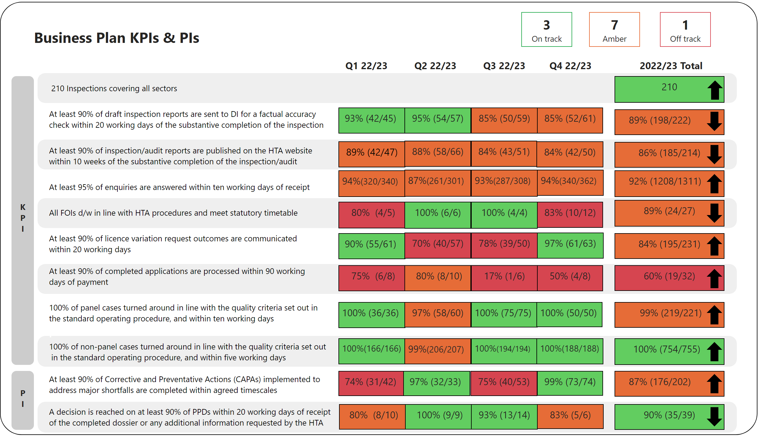

**Change Activities**

|  |  |  |  |  |  |  |  |  |  |
| --- | --- | --- | --- | --- | --- | --- | --- | --- | --- |
|  | Project | Sponsor | Oct 22 | Nov 22 | Dec 22 | Jan 23 | Feb 23 | Mar 23 | 22/23 Year End Position |
| **Activities** | Values and Behaviours | Richard Sydee |  |  |  |  |  |  | Project **completed** |
| Independent Inquiry (Fuller) | Nicolette Harrison |  |  |  |  |  |  | Project **continues** into 23/24 |
| Deemed Consent in NI | Louise Dineley |  |  |  |  |  |  | Project **completed** |
| Compliance updates | Nicolette Harrison |  |  |  |  |  |  | Project **continues** into 23/24 |
| Communications Strategy | Louise Dineley |  |  |  |  |  |  | Project **completed** |
| HTA Fees Review | Richard Sydee |  |  |  |  |  |  | Project **completed** |
| Review of Inspections | Nicolette Harrison |  |  |  |  |  |  | Project **continues** into 23/24 |
| Refresh of IT Equipment | Louise Dineley |  |  |  |  |  |  | Project **completed** |
| IT Shared Services | Louise Dineley |  |  |  |  |  |  | Project **continues** into 23/24 |
| HR Shared Services | Richard Sydee |  |  |  |  |  |  | Project **continues** into 23/24 |
|  | Factual Accuracy Update - Codes | Louise Dineley |  |  |  |  |  |  | Project **completed** |
|  | Data & Security Protection Toolkit | Louise Dineley |  |  |  |  |  |  | Project **continues** into 23/24 |
|  | Explore RIMI | Louise Dineley |  |  |  |  |  |  | Project **continues** into 23/24 |
| **All** | Portfolio | All SMT |  |  |  |  |  |  | Slippage largely due to capacity constraints |

**Annex B – Latest Board Data Overview, 23/24 Latest Position**

**Core Operations**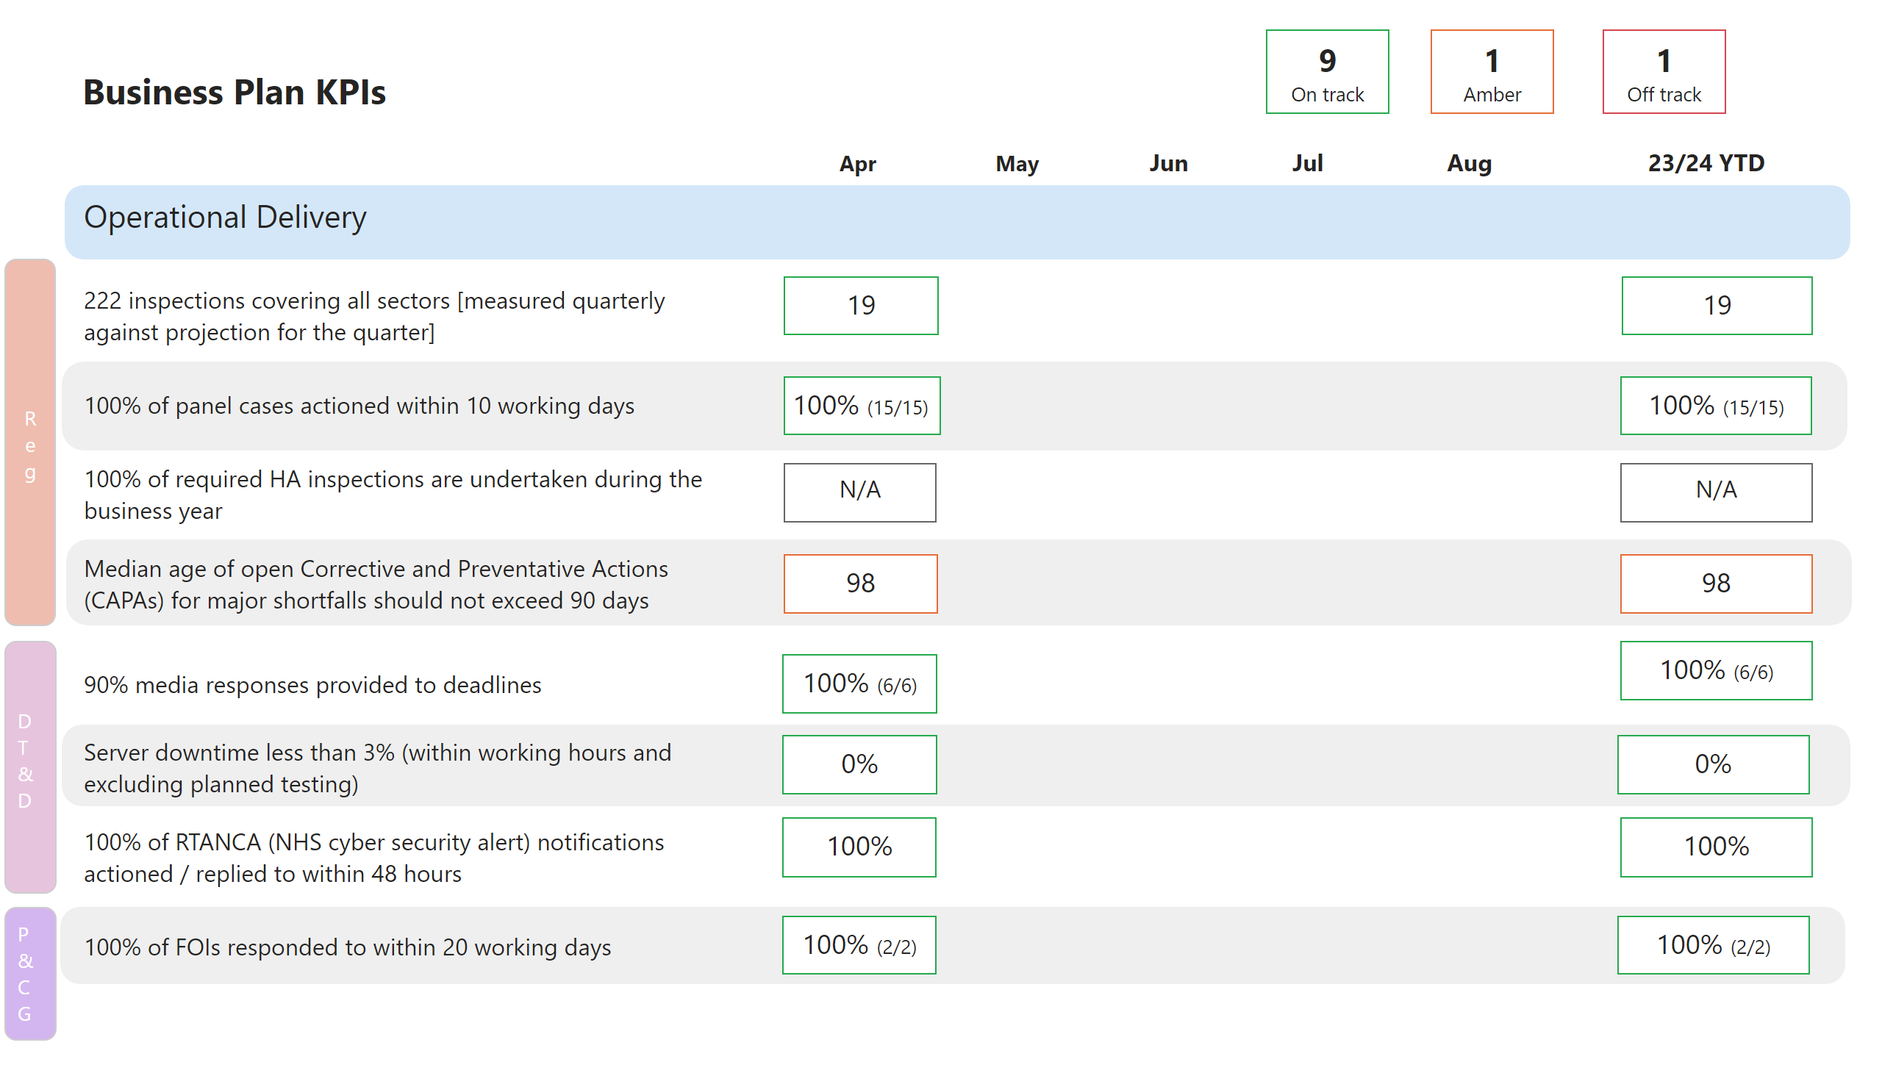

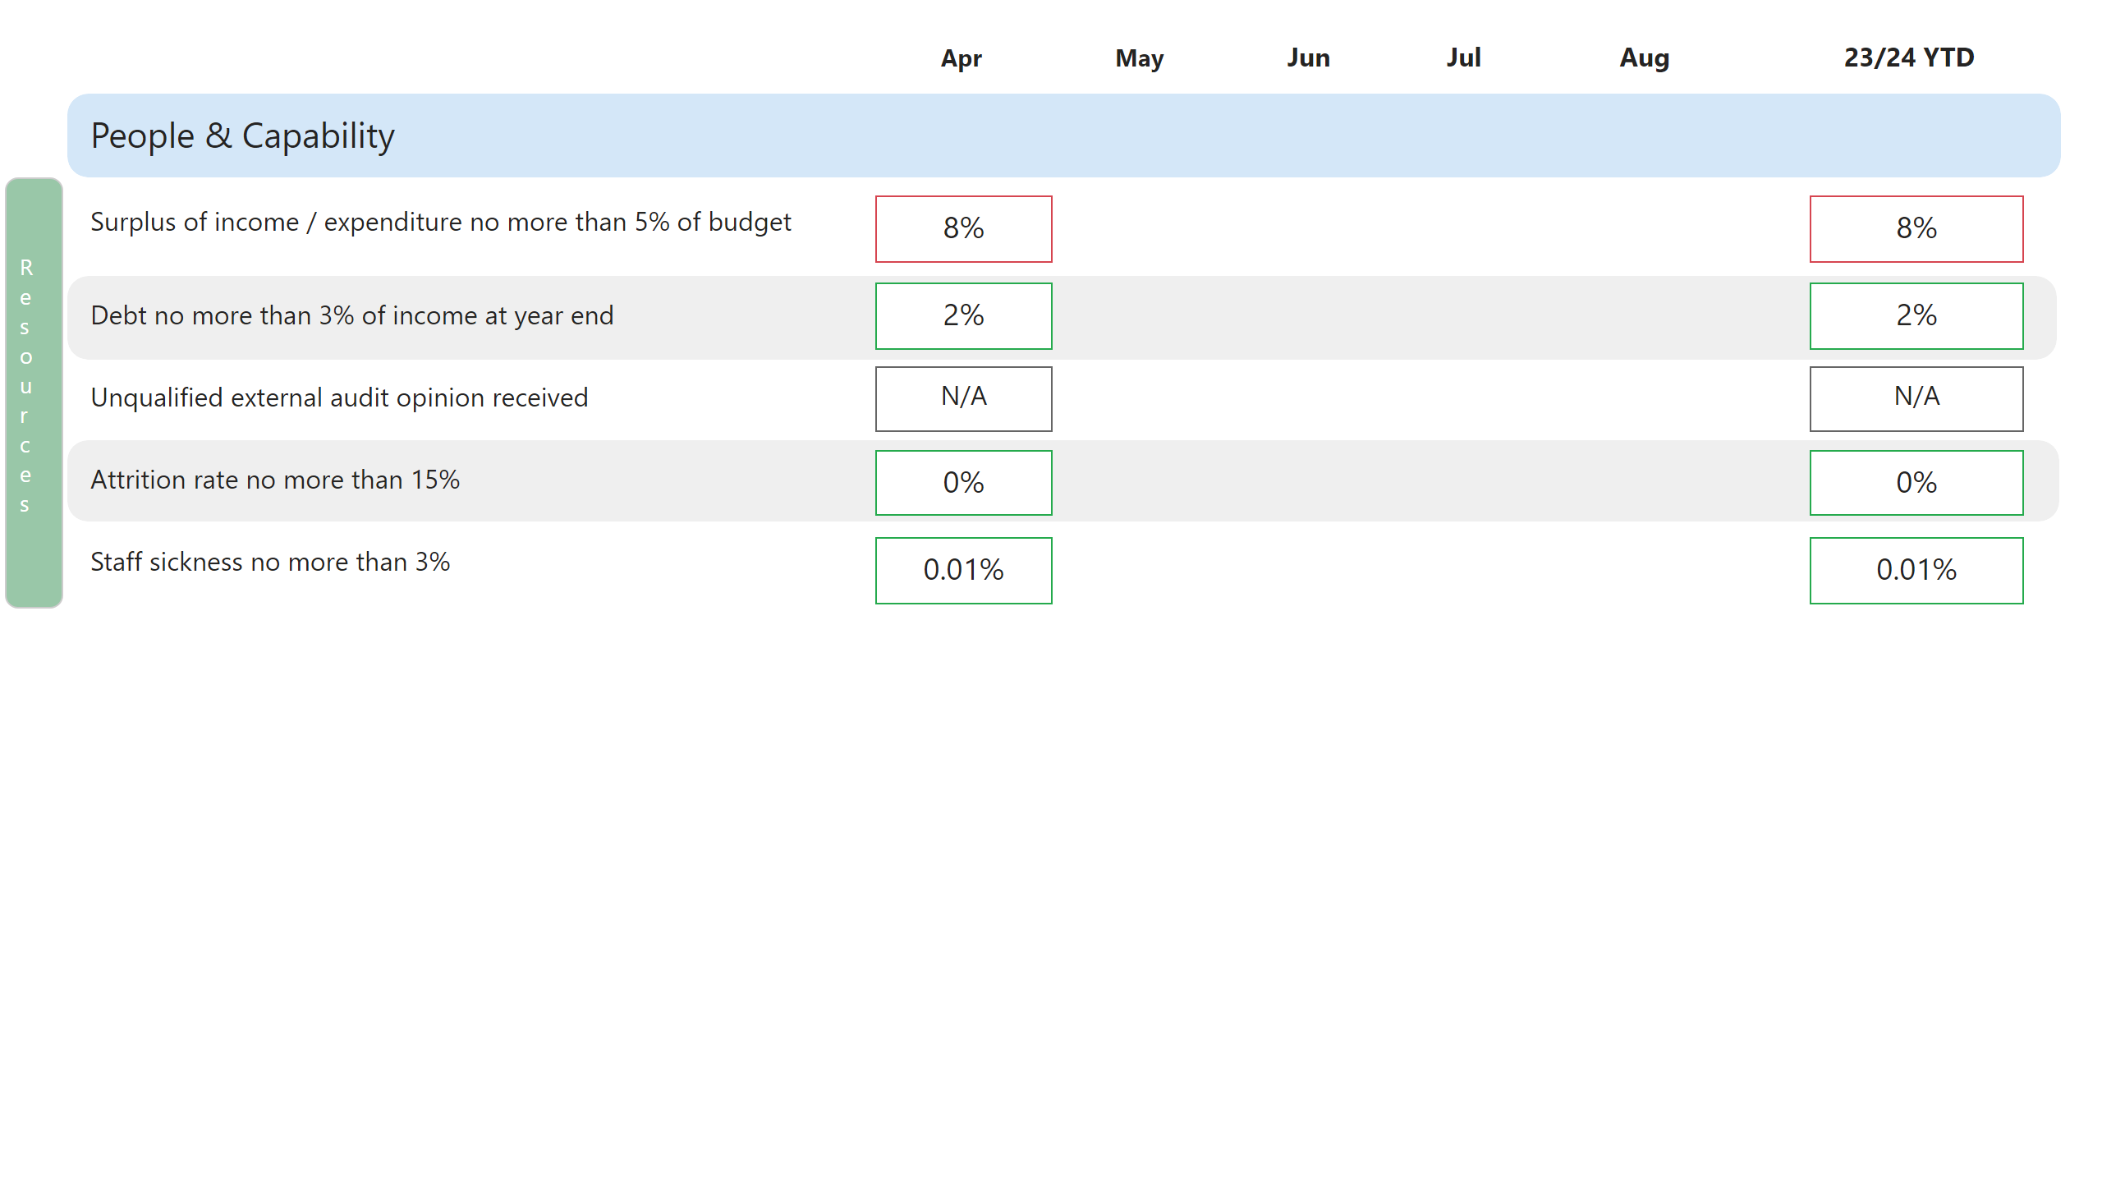

**Change Activities**

|  |  |  |  |  |  |  |
| --- | --- | --- | --- | --- | --- | --- |
|  | Project | Sponsor | Apr 23 | May 23 | Jun 23 | Commentary |
| **Activities** | Create a new HTA strategy | Louise Dineley |  |  |  | Project not yet started – anticipated start date July 23' |
| Public Bodies review | Louise Dineley |  |  |  | Project not yet started – anticipated start date October 23' |
| Assessment of our impact | Louise Dineley |  |  |  | The project group held a kick-off meeting with Kaleidoscope (the consultancy firm that has been appointed to complete the work) and desk-based research and planning for an evaluation framework is underway. The next steps are to finalise the contract / agreement, communicate the aims and objectives with the organisation, and engage with key internal stakeholders |
| Establish an expert advisory group | Louise Dineley |  |  |  | This project is highly dependant on the revision of the horizon scanning process that is being completed as part of BAU activity. However, work is being done to determine the purpose and governance – and to ensure there is internal agreement on the purpose and governance of the Insight Network. |
| Data collection exercise | Nicolette Harrison |  |  |  | A sector-focused data collection exercise to inform our assessment of risk. Questionnaires due to be issued and data returned during Q1 |
| Review of inspections | Nicolette Harrison |  |  |  | External consultants have been appointed following a competitive tendering exercise. Project due to start in Q1 |
| Independent Inquiry (Fuller) | Nicolette Harrison |  |  |  | Continuing activity to provide evidence and input into Sir Jonathan Michael’s Independent Inquiry and take forward other activities as set out in the HTA’s advice to the Secretary of State for Health and Social Care in December 2021 |
| Living Organ Donation approvals | Nicolette Harrison |  |  |  | Work is underway as already agreed by SMT, including finalisation of Board Paper.  There is insufficient capacity within the BAU LOD team to d/w this project and the significant increase in BAU work, some of which directly relates to this process (LOD approvals), other relates to the introduction of s32A HT Act offences.  **Approval for an additional 1 x FTE to increase capacity.** |
| Retained EU Law Bill | Louise Dineley |  |  |  | Project not yet started – anticipated start date July 23' |
| Windsor Framework | Louise Dineley |  |  |  | Project not yet started – anticipated start date July 23' |
| IT strategy requirements | Louise Dineley |  |  |  | Project not yet started – anticipated start date January 24' |
| Records management review | Louise Dineley |  |  |  | Project not yet started – anticipated start date June 23' |
| Finance system review | Richard Sydee |  |  |  | Project not yet started – anticipated start date July 23' |
| People strategy development | Richard Sydee |  |  |  | Project not yet started – anticipated start date January 24' |
| Performance management review | Richard Sydee |  |  |  | Project not yet started – anticipated start date September 23' |
|  | Data & Security Protection Toolkit | Louise Dineley |  |  |  | Work continues in readiness for the final DSPT assessment on Jun 30 and for the Internal Audit (IA) fieldwork which started on 09 May completed on 05 Jun. The IA has scoped 44 assertions for review. At the time of writing GIAA have confirmed, subject to final assessment, that 25 are met, 15 are partially met and 04 have not been met. GIAA are still reviewing evidence and status is expected to improve. This is a considerable improvement since last year. GIAA will be issuing their draft IA report on 09 Jun |
| Develop RIMI (Regulatory Insight Model & Index) | Louise Dineley |  |  |  | Project not yet started – anticipated start date July 23' |
| Start the outsource of IT | Louise Dineley |  |  |  | Project not yet started – anticipated start date July 23' |
| Outsource HR | Richard Sydee |  |  |  | Project not yet started – anticipated start date July 23' |
| Portfolio | All SMT |  |  |  | Overall RAG status for the Portfolio remains at Amber, however, work will need to be undertaken early in Q2 if more Projects are subject to Change Control and anticipated start dates pushed further back |

|  |  |  |  |
| --- | --- | --- | --- |
| **Red** | **Amber** | **Green** | **White** |
| * **Headline:** There is significant risk that the overall Activity will be delivered late or will fail to deliver everything within scope against the agreed baseline plan. | * **Headline:** There is a risk that one or more milestones may be late, or that the full scope will not be delivered. However, there is a good possibility of implementing mitigations to bring the plan back on track to meet the schedule and delivery as planned. | * **Headline:** Overall Activity is on track to be delivered against the baseline plan and there is no or minimal risk of milestones being delivered late. | * **Headline:** Activity not live |

**Annex C**

## 

##### Strategic risk register 2023/24

##### Risk summary: residual risks

| **Risk area** | **Strategy link\*** | **Residual risk** | **Risk owner** | **Status** | **Tolerance** | **Trend\*\*** |
| --- | --- | --- | --- | --- | --- | --- |
| R1: Failure to regulate appropriately | Delivery (a-d & f) and Development (a-d) objectives | **9 - Medium** | Director of Regulation | Below tolerance | **10** | óòóó |
| R2: Failure to manage an incident | Delivery, Development and Deployment objectives | **6 - Medium** | Director of Regulation | At  tolerance | **6** | óóóò |
| R3: Failure to manage expectations of regulation | Delivery (e) and Development (c) | **9 - Medium** | Director of Data, Technology & Development | At tolerance | **9** | óóóó |
| R4: Failure to utilise our staff capabilities effectively | Delivery, Development and Deployment (a, c, and d) | **9 - Medium** | Director of Resources | At tolerance | **9** | ñóòó |
| R5: Insufficient or ineffective management of financial resources | Deployment (b) objective | **4 - Low** | Director of Resources | Above tolerance | **3** | óóóó |
| R6: Failure to take advantage of opportunities that allow the HTA to be an efficient regulator responsive to change and aware of the impact that it has on the sectors and activities that it regulates to ensure public trust and confidence is maintained | Development (a-d) objectives | **9 - Medium** | Director of Data, Technology and Development | At tolerance | **9** | óóóò |
| R7: Failure to optimise the safe use of existing and emerging digital data and technology | Delivery (a-e), Development (a-d)  Deployment (a, c and d) | **12 - High** | Director of Data, Technology and Development | Above tolerance | **9** | óóñó |
| R8: Failure to deliver the agreed Business Plan | Delivery, Development and Deployment objectives | **9 - Medium** | Deputy Director of Performance and Corporate Governance | Above tolerance | **6** | ó |
| R9: Failure to adhere to our corporate responsibilities | Delivery, Development and Deployment objectives | **9 - Medium** | Director of Resources | Above tolerance | **6** | ó |

* Strategic objectives 2021-2024:

** This column tracks the four most recent reviews by SMT (Senior Management Team) (e.g.ñÛòÛ).

## R1: There is a risk that we fail to regulate in a manner that maintains public safety and confidence and is appropriate

|  |  |  |  |  |  |
| --- | --- | --- | --- | --- | --- |
| **Inherent risk level:** | | | **Residual risk level:** | | |
| Likelihood | Impact | Inherent risk | **Likelihood** | **Impact** | **Residual risk** |
| 3 | 5 | 15 - High | **3** | **3** | **9 - Medium** |
| **Tolerance threshold:** | | | | | **10 - Medium** |

|  |
| --- |
| **Commentary** |
| **Below tolerance.**  We believe we have a sound regulatory framework, which we continue to evolve in response to emerging risks and our own desire to continue to be risk-based, proportionate and data-driven.  We have not identified any underlying or systemic failures or weaknesses in our approach to regulation that would contribute to a loss of public safety and confidence. We received an assessment of substantial assurance on the previous internal audit on key regulatory processes (final report issued 16 April 2019). We received an assessment of moderate assurance on the internal audit on the Effectiveness of the Inspection Process (final report issued 11 April 2022).  Three out of the five recommendations have been accomplished on time, with two having an agreed deferred due date during the 2023/24 business year.  Recent activity with the potential to raise public concern about the changing nature of risk in the Living Organ Donation sector has included information in the public domain concerning people trafficking for organ donation and changes to the offences in the Human Tissue Act to introduce an extra-territorial offence for organ tourism. The HTA continues to play a significant role in multi-agency efforts to address these issues as well as undertaking actions ourselves to address the changing nature of risk and to ensure clear, robust and proportionate messaging.  The recent internal audit on the LOD approval process (final report issued 28 March 2023), including our internal review, gave moderate assurance overall, recognising that whilst our review and processes were robust, the risk profile of this activity was changing. We are in the process of making changes to our processes, including training for Independent Assessors and HTA staff and Board members involved in LOD approvals, to implement the recommendations of this audit. This will be covered in a paper to the Board in June 2023.  The HTA is continuing to evolve our approach to inspection, one of our core regulatory tools, introducing Evaluated Self-Assessments (EVAs) this year. We are further increasing our inspection coverage to 222 inspections on existing licences, plus full assessment of all new licence applications. The significant increase in inspection coverage over the last two years, plus the continuing publication of inspection reports and updates to the website to make these more visible, help provide public reassurance, as do the regular publication of data on incidents and our ongoing communications and engagement strategy.  The new suite of KPIs, reported quarterly to the Board and published in those Board Papers, provides public assurance on our delivery of core regulatory functions.  We prepare suitable public and media comment, at an appropriate time, on those cases we refer to the police for further investigation and which are taken forward for prosecution, ensuring alignment of messaging where appropriate with other relevant stakeholders.  We continue to support Sir Jonathan Michael’s Independent Investigation into offending at a hospital mortuary and continue to pursue a programme of related activity, including with wider sector stakeholders, as set out in our published advice to the Secretary of State in December 2021.  We continue to use all other regulatory tools and processes, such as managing and responding to incident reports (Serious Adverse Events and Reactions and HTA Reportable Incidents), whistleblowing / informant information and ongoing engagement with our regulated sectors, adopting a wide range of approaches for dealing with issues of concern, including investigations and unannounced inspection where relevant.  SMT believes this risk is now reduced to just below tolerance. |

## R2: There is a risk that we will be unable to manage the lifecycle of a significant incident, event or issue impacting on the delivery of HTA objectives

|  |  |  |  |  |  |
| --- | --- | --- | --- | --- | --- |
| **Inherent risk level:** | | | **Residual risk level:** | | |
| Likelihood | Impact | Inherent risk | **Likelihood** | **Impact** | **Residual risk** |
| 4 | 5 | 20 – Very high | **2** | **3** | **6 – Medium** |
| **Tolerance threshold:** | | | | | **6 – Medium** |

|  |
| --- |
| **Commentary** |
| **At tolerance.**  This risk concerns our ability to respond to and manage the whole lifecycle of incidents, irrespective of their nature or cause i.e. these are not necessarily incidents relating to our regulatory remit.  Given this risk concerns our ability to respond to an incident whilst maintaining delivery of core business objectives, we believe it is within the HTA’s control through the use of the Critical Incident and Business Continuity Plans (or based on those approaches). Hence we have set a low tolerance level.  The HTA believes that our incident management response plans have been tested and found effective through their deployment in several different circumstances over the past few years. These have included managing the impact of the pandemic and related restrictions, in their adaptation for use in managing the potential impacts of EU Exit following the end of the Transition Period and in our mobilisation planning in preparation for the Fuller trial.  We have rewritten our Critical Incident Response Plan and tested it during 22/23 with a specialist consultant and will complete a similar exercise for our Business Continuity Plan in Q1 23/24. Moving forward we will review both procedures annually and undertake a test with all staff each January to ensure that we are sufficiently prepared to manage incidents as they arise.  Having increased the risk scoring in July 2021, in anticipation of the prospective Fuller trial, we now believe that the likelihood of this risk materialising has reduced. Sir Jonathan Michael’s Independent Inquiry into the circumstances of Fuller’s offending and any related wider concerns about settings in which the deceased are managed is still continuing and is expected to report on Phase 1 during 2023 and on Phase 2 in 2024. Given there are also other criminal proceedings concerning unrelated matters within our broader remit, we believe there is still the potential for significant impact of an incident, on our corporate objectives, either from those causes or others of which we may still be unaware.  Hence the residual risk is now at the tolerance level, a reduction unchanged from the last review. |

## R3: There is a risk that we will fail to manage public and professional expectations of human tissue regulation stemming from limitations in current legislation, misperception of HTA regulatory reach and innovations in the use of human tissues and cells

|  |  |  |  |  |  |
| --- | --- | --- | --- | --- | --- |
| **Inherent risk level:** | | | **Residual risk level:** | | |
| Likelihood | Impact | Inherent risk | **Likelihood** | **Impact** | **Residual risk** |
| 3 | 4 | 12 - High | **3** | **3** | **9 – Medium** |
| **Tolerance threshold:** | | | | | **9 – Medium** |

|  |
| --- |
| **Commentary– to be updated based on agreement of the risk** |
| **At tolerance.**  The HTA is approaching the end of the first year of delivering and embedding its Communications & Engagement Strategy. The strategy is underpinned by a commitment for more proactive and open in our communication and engagement with professionals and the public. In the last year this has been tested through day to day operational activity with improvements informed and impact evidenced through website analytics, feedback and a better understanding of how HTA communication and engagement channels are used. A similar approach has been adopted in our engagement with professionals with the establishment of sector based forums and roundtable events. These forums and events have been used to explore specific and emerging issues identified through horizon scanning and specific issues relating to the regulatory approach, sector based practice or the legislative framework. The combined impact of this work reflects an opportunity to clarify and confirm the vision and mission of the HTA and how we work to deliver the safe use of tissues and cells.  The HTA acknowledges that to continue to regulate effectively it is important that it understand the impact of its activities whilst at the same time continuing to be responsive to innovation and growth across Life Sciences. The HTA has recently started a piece of work that seeks to assess the impact of the HTA as a regulator and its activities. This will culminate in a publication the aim of which will be to share insight and feedback on the regulated activities and sectors and promote public confidence in the safe use of tissues and cells.  Looking ahead at 2023/24 the HTA will be reviewing its Strategy. This will set the direction of travel for the next 3 years and potentially beyond as well as showcasing the ongoing importance of regulating the use of human tissues and cells.  SMT consider this risk to be at tolerance. |

**R4: Failure to adequately deliver the diverse, capable workforce the HTA requires or needs to fulfil its functions and objectives**

|  |  |  |  |  |  |
| --- | --- | --- | --- | --- | --- |
| **Inherent risk level:** | | | **Residual risk level:** | | |
| Likelihood | Impact | Inherent risk | **Likelihood** | **Impact** | **Residual risk** |
| 4 | 3 | 12 - High | **3** | **3** | **9 - Medium** |
| **Tolerance threshold:** | | | | | **9 – Medium** |

|  |
| --- |
| **Commentary** |
| **At tolerance.**  We start of the 2023/34 business year with far fewer vacancies to fill that the same period last year. Churn and recruitment have returned to within expected tolerances, and with the exception of one IT post, we have been able to successfully fill most vacancies from the initial recruitment round.  Retention of colleagues will remain an issue, our overall package of salary and benefits remains competitive across the public sector sphere in which we operate – although headline gross pay does not always seem competitive with the NHS. Our revised approach to advertising, and the work to review our salary bands, will manage internal and external expectations around salary – although the continued absence of real terms pay progression to band maximum will likely mean that churn will remain an issue and the lack of progression within the organisation a barrier to retaining necessary internally developed skills. We must continue to acknowledge that a number of our functions rely on single individuals and that unexpected departures in key roles will inevitably impact on delivery of some key outputs in the short term – this risk is further exacerbated by the difficulty current DHSC controls on the use of contingent labour.  The transition to outsourced shared services should not impact significantly on key HR operations as we transition and in the medium term we feel this will provide a greater breadth of options and services available to our colleagues. There will need to be careful management of areas such as corporate training and organisational development to ensure that this is not lost sight of as internal HR colleagues are required to focus more on transition and handover to CQC. |

## R5: There is a risk that the HTA has insufficient or ineffective management of its financial resources

|  |  |  |  |  |  |
| --- | --- | --- | --- | --- | --- |
| **Inherent risk level:** | | | **Residual risk level:** | | |
| Likelihood | Impact | Inherent risk | **Likelihood** | **Impact** | **Residual risk** |
| 4 | 5 | 20 – Very high | **2** | **2** | **4 – Low** |
| **Tolerance threshold:** | | | | | **3 – Low** |

|  |
| --- |
| **Commentary** |
| **Above tolerance.**  Budgets for 2023/24 have been agreed and delegation letters to Directors issued. Our Grant in Aid (GIA) funding from the Department has initially been confirmed at previous levels and we have been provided with cover for asset purchases (Capital DEL - £30k) and depreciation and amortisation costs (Ring Fenced RDEL). Submissions have been made to Ministers regarding options to generate reductions in GIA delegations for 2023/24 and 2024/25 and we await the conclusion of that exercise. The position of the HTA is to make no reductions in the 2023/24 GIA.  The budget for 2023/24 has absorbed a number of pressures, including additional costs related to the support of the Independent Inquiry, these were met by the DHSC last year. We have part funded a number of work programmes at the start of the year with the expectation that underspends will emerge though staff churn, and that licence fee income will again significantly overshoot our estimate. This will need to be carefully managed through the first and second quarters of the financial year and could require decisions to pause some programmes work before completion to ensure that the HTA does not exceed its spending controls.  The departure of the incumbent Director of Finance & Resources will lead to additional workload pressures on the team for the remainder of the year – both in terms of the gap before the new Director starts and the onboarding process for the new incumbent. |

## R6: Failure to take advantage of opportunities that allow the HTA to be an efficient regulator responsive to change and aware of the impact that it has on the sectors and activities that it regulates to ensure public trust and confidence is maintained

|  |  |  |  |  |  |
| --- | --- | --- | --- | --- | --- |
| **Inherent risk level:** | | | **Residual risk level:** | | |
| Likelihood | Impact | Inherent risk | **Likelihood** | **Impact** | **Residual risk** |
| 4 | 3 | 12 - High | **3** | **3** | **9 – High** |
| **Tolerance threshold:** | | | | | **9 – Medium** |

|  |
| --- |
| **Commentary** |
| **At tolerance.**  This risk has been updated and redefined for 2023/24 to reflect a central priority supporting efficiency and reform. As with risk 3 the HTA has progressed and delivered a number of projects in the post pandemic period reflecting changes in the way that it works and to ensure it remains responsive to opportunities for working differently. The 2023/24 Business Plan includes a number of projects that will impact this direction of travel. Activities under risk 3 and this risk 6 coalesce to support the HTA’s vision and mission.  It is anticipated that updates on the risk will reflect the progress of identified projects and align with updates and actions identified across other risks specifically risks 3, 4, 5 & 7. This alignment is critical as in previous years the availability of resources (people and financial) have been significant factors in setting the pace and appetite for change. A further consideration and alignment opportunity for the HTA will be with the myriad of central initiatives and programmes that see to take advantage of economies of scale and consolidation of improvement opportunities and skills. |

## R7: Failure to optimise the safe use of existing and emerging digital data and technology

|  |  |  |  |  |  |
| --- | --- | --- | --- | --- | --- |
| **Inherent risk level:** | | | **Residual risk level:** | | |
| Likelihood | Impact | Inherent risk | **Likelihood** | **Impact** | **Residual risk** |
| 4 | 4 | 16 – High | **4** | **3** | **12 – High** |
| **Tolerance threshold:** | | | | | **9 – Medium** |

|  |
| --- |
| **Commentary** |
| **Above tolerance.**  Over the last 2 years the HTA has been progressing with the planned development of its digital data and technology (systems and architecture) as part of the Development Programme. The planned development had been incremental based on available resources and aimed to future proof business needs.  Two projects were identified in 2022/23. These were (1) the adoption of an IT Shared Services model and (2) stage 2 development of the Regulatory Insight Model and Index. As identified under risk 6 progress has not been possible due to resource constraints. The HTA’s IT function has been an area of consistent pressure and over commitment of internal resource for a number of years. As part of the 2023/24 business plan there has been confirmation of a substantive Head of IT position. The identified resource is positive however given the competitive IT recruitment market, successful recruitment is a risk. A revised recruitment plan and approach has been identified and will be shared with RemCo.  As with risk 6 the HTA’s ability to optimise the use of existing and emerging data, digital and technology opportunities is largely reliant on investment and resource. There is a clear vision and confidence in what could be delivered although the reliance on single roles in this area and wider ambitions means that substantive recruited resource is at capacity.  At the start of 2023/24 this risk is above tolerance. |

## R8: Failure to deliver the agreed Business Plan

|  |  |  |  |  |  |
| --- | --- | --- | --- | --- | --- |
| **Inherent risk level:** | | | **Residual risk level:** | | |
| Likelihood | Impact | Inherent risk | **Likelihood** | **Impact** | **Residual risk** |
| 3 | 4 | 12 – High | **3** | **3** | **9 – Medium** |
| **Tolerance threshold:** | | | | | **6 – Medium** |

|  |
| --- |
| **Commentary** |
| **Above tolerance.**  The 23/24 Business Plan has been created through a codesign process involving Board and staff such that we are confident that it is both challenging but achievable.  We operate a formal Portfolio Management approach to the management of our Business Plan delivery, with explicit processes and best practice outputs tracking progress and scrutiny at Business Delivery Team (middle management) fortnightly, Portfolio SMT (senior management) monthly and Board quarterly.  Portfolio Management allows us to be flexible in-year so that as we are reviewing our performance, we can also consider additional requests and pressures as they arise, refining our Business Plan through change control and redeploying resources as needed.  To date, progress to deliver the 23/24 Business Plan has been noted as acceptable, albeit that a number of indicative project start dates have been adjusted through change control to later in the year.  This risk is currently considered slightly above tolerance on the basis that we have an ambitious Business Plan and anticipate that any repetition of staffing issues from 22/23 or the wider financial pressures and the drive for efficiencies from government may mean that we have to scale back our ambitions in-year. It is hoped that we will be able to bring this risk back to tolerance as we progress through the business year and start delivering outputs. |

**Reviews and revisions**

**(25/04/23) SMT review April/May 2023**

At its meeting in April, the SMT reviewed each of its Strategic risks. There was discussion around whether we have sufficient breadth of risk and whether a risk that focused on data and digital was needed in addition to the risk around delivery of the Development programme. It was agreed that each risk owner should review their risk descriptions and in addition create 2 new risks around business plan delivery and strategy – strategic direction. A risk focussing on compliance is to be discussed at the next meeting.

**(23/05/23) SMT review May/June 2023**

At its May meeting, the SMT agreed the re-wording of risk 2 and a reduction in the likelihood. Risk 4 has been amended to reflect not just recruitment and vacancies but to reflect risks around the workforce.

Risk 5 has been re-cast, however, SMT felt that the tolerance level was too low and that this will be brought to ARAC in June to discuss a recommendation to the Board to increase it to 4.

Risks 6 has been split into two (risk 6 and risk 8) to reflect risks around our strategy and our business planning.

There is a final risk which requires further discussion. The risk update paper presented to ARAC in June will refer to this risk and the need for discussion.

1. Is one ALB, and the account was cleared in June 2023.
2. Includes Universities and private organisations